**Deccan Education Society’s**

**Navinchandra Mehta Institute of Technology and Development**

# CERTIFICATE

my supervision in this college during the year 2022-2023.

|  |  |  |  |  |  |
| --- | --- | --- | --- | --- | --- |
| CO | R1  (Attendance) | R2  (Performance during lab session) | R3  (Innovation in problem solving technique) | R4  (Mock  Viva) | R5  (Variation in implementation of learnt topics on projects) |
| CO1 |  |  |  |  |  |
| CO2 |  |  |  |  |  |
| CO3 |  |  |  |  |  |
| CO4 |  |  |  |  |  |

Practical-in-charge Head of Department

MCA Department

(NMITD)

**INDEX**

|  |  |  |  |  |
| --- | --- | --- | --- | --- |
| **SR NO** | **NAME OF THE EXPERIMENT** | **DATE** | **FACULTY SIGN** | **CO** |
| **1** | HDFS: List of Commands (mkdir, touchz, copy from local/put, copy to local/get, move from local, cp, rmr, du, dus, stat) | 25/9/2023 |  | **CO1** |
| **2** | Map Reduce:  1. Write a program in Map Reduce for Word Count operation.  2. Write a program in Map Reduce to find average word count.  3. Write a program in Map Reduce to demonstrate sorting operation.  4. Write a program in Map Reduce for Matrix Multiplication | 9/10/2023 |  | **CO2** |
| **3** | MongoDB:  1. Installation  2. Sample Database Creation  3. Query the Sample Database using MongoDB querying commands  a. Create Collection  b. Insert Document  c. Query Document  d. Delete Document  e. Indexing | 16/10/2023 |  | **CO3** |
| **4** | HiveQL: Select Where, Select OrderBy, Select GroupBy, Select Joins Hive:  1. Hive Data Types  2. Create Database & Table in Hive  3. Hive Partitioning  4. Hive Built-In Operators  5. Hive Built-In Functions  6. Hive Views and Indexes | 30/10/2023 |  | **CO4** |
| **5** | Pig:  1. Pig Latin Basic  2. Pig Data Types,  3. Download the data  4. Create your Script  5. Save and Execute the Script  6. Pig Operations: Diagnostic Operators, Grouping and Joining, Combining & Splitting, Filtering, Sorting | 11/12/2023 |  | **CO4** |
| **6** | Spark:  1. Downloading Data Set and Processing it Spark  2. Word Count in Apache Spark. | 12/12/2023 |  | **CO5** |
| **7** | Visualization using Tableau:  Tableau: Tool Overview, Importing Data, Analyzing with Charts, Creating Dashboards, working with maps, | 13/12/2023 |  | **CO6** |

**Practical 1**

HDFS: List of Commands (mkdir, touchz, copy from local/put, copy to local/get, move from local, cp, rmr, du, dus, stat)

HDFS is the primary or major component of the Hadoop ecosystem which is responsible

For storing large data sets of structure do run structured data across various nodes and there by maintaining the meta data in the form of log files. The File System (FS) shell includes various shell-like commands that directly interact with the Hadoop Distributed File System (HDFS) as well as other file systems that Hadoop supports, such as Local FS, Web HDFS, S3 FS, and others.

HadoopCommands:

1. mkdir: Creates a directory under Hadoop Ecosystem

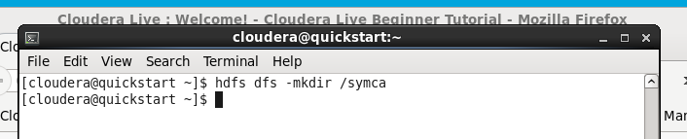

1. touchz: Creates a file named under Hadoop File System

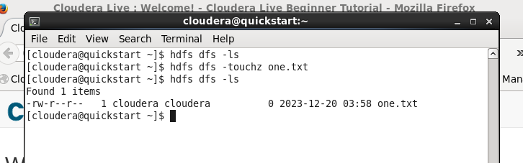

1. CopyFromLocal: Copy files from local File system to Hadoop File System

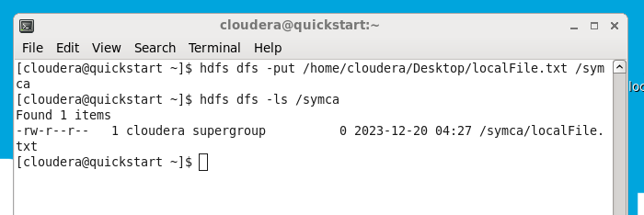

1. copyToLocal: Copy files from Hadoop File System to Local File System

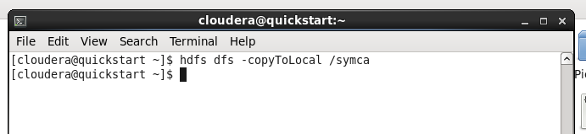

1. cp: Copy files from one directory to another directory within the Hadoop File System

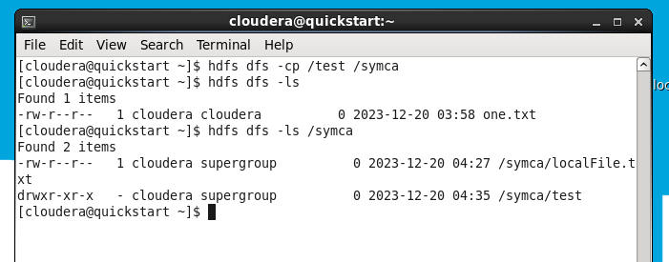

1. rm r: Removes the files or directory from the given path

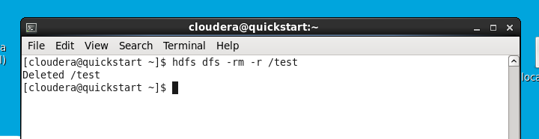

1. du s: Prints a summary of disk usage of all files/directories in the path

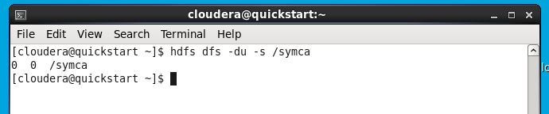

1. stat: Prints information about the path

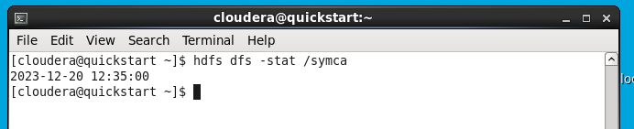

**Practical 2**

What is MapReduce?

MapReduce is a programming paradigm that enables massive scalability across hundreds or thousands of servers in a Hadoop cluster. As the processing component, MapReduce is the heart of Apache Hadoop. The term "MapReduce" refers to two separate and distinct tasks that Hadoop programs perform.

The first is the map job, which takes a set of data and converts it into another set of data, where individual elements are broken down into tuples (key/value pairs). The reduce job takes the output from a map as input and combines those data tuples into a smaller set of tuples. As the sequence of the name MapReduce implies, the reduce job is always performed after the map job. MapReduce programming offers several benefits to help you gain valuable insights from your big data:

* + Scalability. Businesses can process petabytes of data stored in the Hadoop Distributed File System (HDFS).
  + Flexibility. Hadoop enables easier access to multiple sources of data and multiple types of data.

Speed. With parallel processing and minimal data movement, Hadoop offers fast processing of massive amounts of data.

1. Write a program in Map Reduce for Word Count operation.

Step 1: Open virtual box and then start cloudera quickstart

Step 2: Open eclipse present on the cloudera desktop

Step 3: Create java project

File->New-> Java Project

Give project name: WordCount

Click Next

Step 4: Add Hadoop libraries to project

Select Libraries tab->click on Add Externa Jars

File System->user->lib->Hadoop

Select all library(jar) files->ok

Again click on Add Externa Jars

File System->user->lib->Hadoop->client

Select all library(jar) files from client->ok->finish

Step 5: Write java code for word count

Right click on src folder of project WordCount

New->class

Write class name WordCountDriver

Click Finish

Write the code for WordCountDriver

Same way create classes WordMapper and SumReducer

Step 6: Export the project as jar

Right click on project WordCount and select Export>> Java>>JAR file>>Next

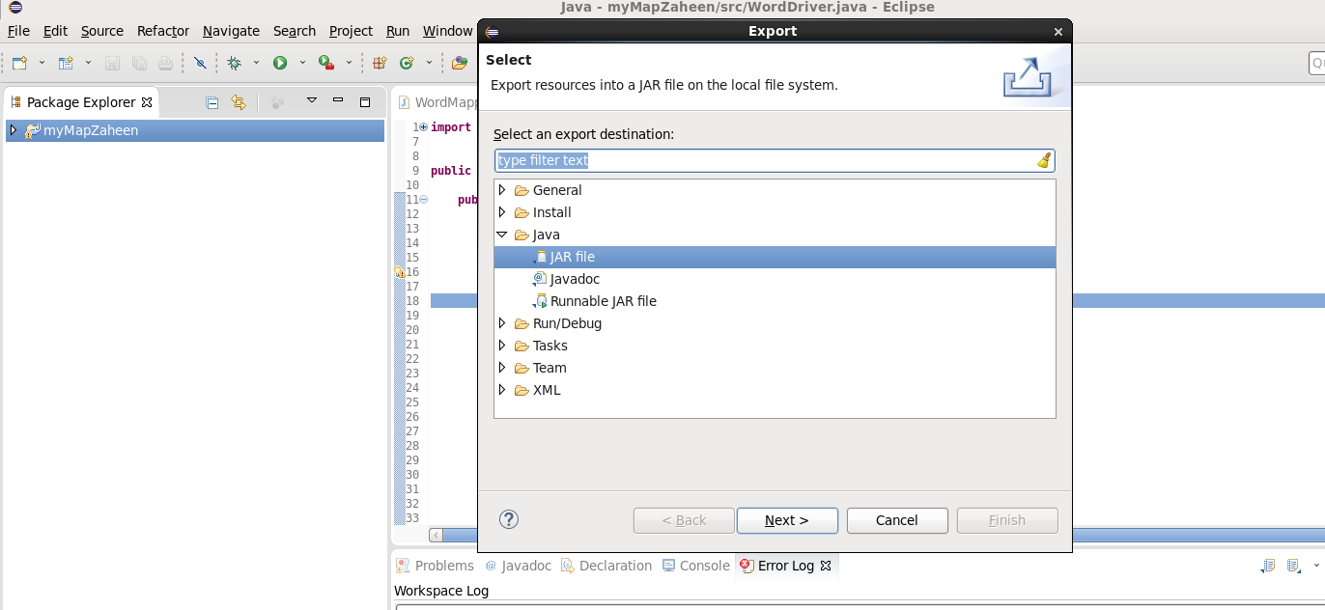

Select the export destination-Click browse-give file name wordcount.jar Click ok>>Finish>>ok

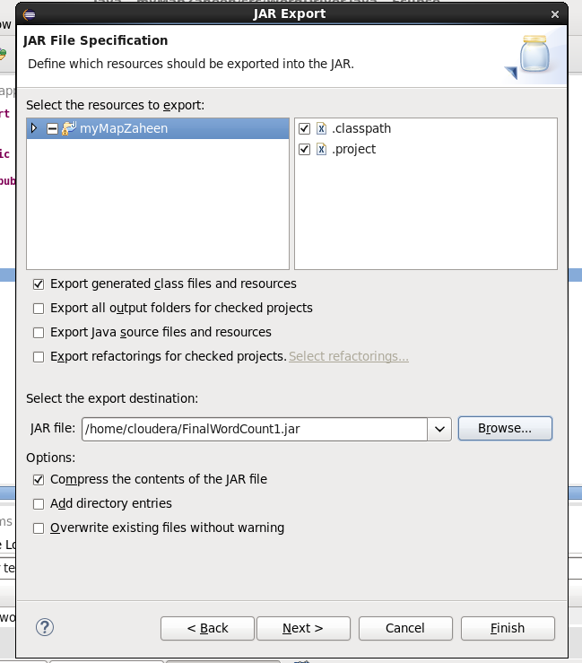

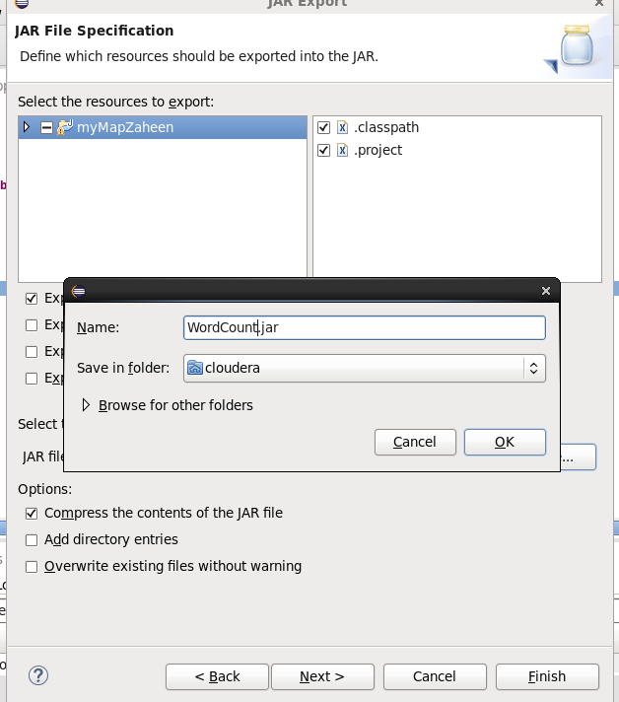

Verify the jar file

Verify the jar file through command line open terminal give command

**ls**

step 7: Move the jar file to the Hadoop file system

**hdfs dfs -put wordcount.jar /user/cloudera**

**hdfs dfs -ls**

Step 8: Create the input file for the MapReduce program

Step 9: Move the input file to the Hadoop file system

**hdfs dfs -put myInputFile.txt /user/cloudera**

**hdfs dfs -ls**

**hdfs dfs –ls /** (here / indicates root directory of Hadoop file system(hdfs))

step 10: Run mapreduce program on Hadoop

syntax: hadoop jar jarfilename.jar classname inputfilename.txt outputfoldername

command: **hadoop jar wordcount.jar WordCountDriver myInputFile.txt myOutput**

step 11: view output directory

**hdfs dfs –ls**

**hdfs dfs -ls /user/cloudera/myOutput**

step 12: view the output file

**hdfs dfs -cat /user/cloudera/myOutput/part-r-00000**

(WordCountDriver.java)

import org.apache.hadoop.fs.Path;

import org.apache.hadoop.io.IntWritable;

import org.apache.hadoop.io.Text;

import org.apache.hadoop.mapreduce.Job;

import org.apache.hadoop.mapreduce.lib.input.FileInputFormat;

import org.apache.hadoop.mapreduce.lib.output.FileOutputFormat;

public class WordCountDriver {

   public static void main(String[] args) throws Exception{

      if(args.length != 2){

         System.out.printf("Usage:WordCount <input dir> <output dir>\n");

         System.exit(-1);;

      }

      Job job = new Job();

      job.setJarByClass(WordCountDriver.class);

      job.setJobName("Word Count");

      FileInputFormat.setInputPaths(job, new Path(args[0]));

      FileOutputFormat.setOutputPath(job, new Path(args[1]));

      job.setMapperClass(WordMapper.class);

      job.setReducerClass(SumReducer.class);

      job.setMapOutputKeyClass(Text.class);

      job.setOutputValueClass(IntWritable.class);

      job.setOutputKeyClass(Text.class);

      job.setOutputValueClass(IntWritable.class);

      boolean success = job.waitForCompletion(true);

      System.exit(success?0:1);

   }

}

(WordMapper.java)

import java.io.IOException;

import org.apache.hadoop.mapreduce.Mapper;

import org.apache.hadoop.io.IntWritable;

import org.apache.hadoop.io.LongWritable;

import org.apache.hadoop.io.Text;

public class WordMapper extends Mapper<LongWritable, Text, Text, IntWritable> {

   public void map(LongWritable key, Text value, Context context) throws IOException, InterruptedException{

      String line = value.toString();

      for(String word:line.split("//W+")){

         if(word.length()>0){

            context.write(new Text(word), new IntWritable(1));

         }

      }

   }

}

(SumReducer.java)

import java.io.IOException;

import org.apache.hadoop.mapreduce.Reducer;

import org.apache.hadoop.io.IntWritable;

import org.apache.hadoop.io.Text;

public class SumReducer extends Reducer<Text, IntWritable, Text, IntWritable>{

   public void reduce(Text key, Iterable<IntWritable> values, Context context) throws IOException, InterruptedException{

      int wordCount = 0;

      for(IntWritable value:values){

         wordCount+=value.get();

      }

      context.write(key, new IntWritable(wordCount));

   }

}

**Output**





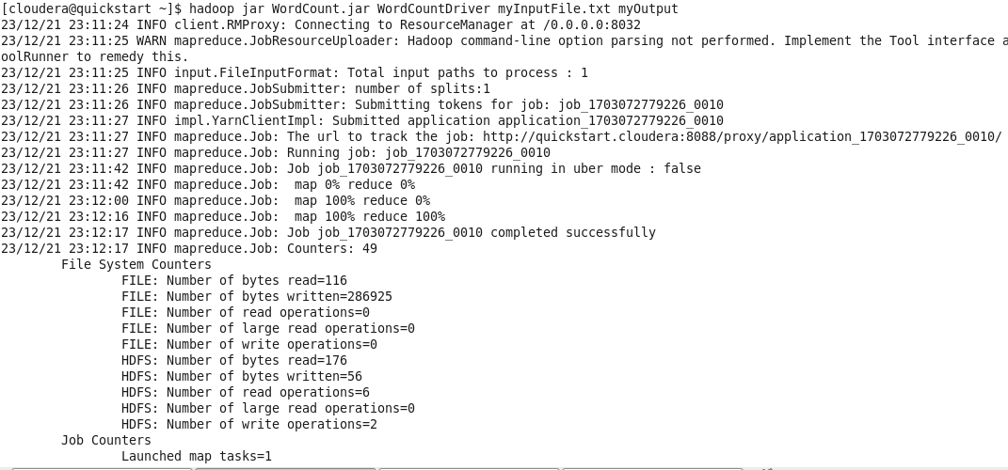

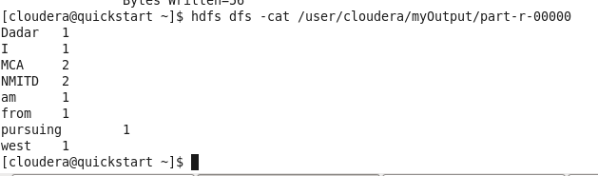

1. Write a program in Map Reduce to find average word count.

Step 1: Open virtual box and then start cloudera quickstart

Step 2: Open eclipse present on the cloudera desktop

Step 3: Create java project

File->New-> Java Project

Give project name: AvgWordCount

Click Next

Step 4: Add Hadoop libraries to project

Select Libraries tab->click on Add Externa Jars

File System->user->lib->Hadoop

Select all library(jar) files->ok

Again click on Add Externa Jars

File System->user->lib->Hadoop->client

Select all library(jar) files from client->ok->finish

Step 5: Write java code for Sorting using mapreduce

Right click on src folder of project AvgWordCount

New->class

Write class name AvgDriver

Click Finish

Write the code for AvgWordCountDriver

Same way create classes AvgMapper and AvgReducer

Step 6: Export the project as jar

Right click on project Sorting and select Export>> Java>>JAR file>>Next

Select the export destination-Click browse-give file name AvgWordCount.jar Click ok>>Finish>>ok

Verify the jar file

Verify the jar file through command line open terminal give command

**ls**

step 7: Move the jar file to the Hadoop file system

**hdfs dfs -put AvgWordCount.jar /user/cloudera**

**hdfs dfs -ls**

Step 8: Create the input file for the MapReduce program

Step 9: Move input files into it.

**hdfs dfs -put myInputFile.txt /user/cloudera/**

**hdfs dfs -ls**

step 10: Run mapreduce program on Hadoop

syntax: hadoop jar jarfilename.jar classname inputfoldername outputfoldername

command: **hadoop jar AvgWordCount.jar AvgDriver myInputFile.txt ResultAvg**

step 11: view output directory

**hdfs dfs –ls**

**hdfs dfs -ls /user/cloudera/ResultAvg**

step 12: view the output file

## **hdfs dfs -cat /user/cloudera/ResultAvg/part-r-00000**

## AvgDriver.java

import org.apache.hadoop.fs.Path;

import org.apache.hadoop.io.FloatWritable; import org.apache.hadoop.io.Text;

import org.apache.hadoop.mapreduce.lib.input.FileInputFormat;

import org.apache.hadoop.mapreduce.lib.output.FileOutputFormat; import org.apache.hadoop.mapreduce.Job;

public class AvgDriver {

public static void main(String[] args) throws Exception { if (args.length != 2) {

System.out.printf("Usage: WordCount <input dir> <outpudir>\n");

System.exit(-1);

}

Job job = new Job();

job.setJarByClass(AvgDriver.class); job.setJobName("Word Count");

FileInputFormat.setInputPaths(job, new Path(args[0])); FileOutputFormat.setOutputPath(job, new Path(args[1]));

job.setMapperClass(AvgMapper.class);

job.setReducerClass(AvgReducer.class);

job.setMapOutputKeyClass(Text.class);

job.setMapOutputValueClass(FloatWritable.class);

job.setOutputKeyClass(Text.class);

job.setOutputValueClass(FloatWritable.class);

boolean success = job.waitForCompletion(true); System.exit(success ? 0 : 1);

}

}

## AvgMapper.java

import java.io.IOException;

import org.apache.hadoop.io.FloatWritable; import org.apache.hadoop.io.LongWritable; import org.apache.hadoop.io.Text;

import org.apache.hadoop.mapreduce.Mapper;

public class AvgMapper extends Mapper<LongWritable, Text, Text, FloatWritable> {

@Override

public void map(LongWritable key, Text value, Context context) throws IOException, InterruptedException {

String line = value.toString();

for (String word : line.split("\\W+")) { if (word.length() > 0) {

context.write(new Text(word), new

FloatWritable(1));

}

}

}

}

## AvgReducer.java

import java.io.IOException;

import org.apache.hadoop.io.FloatWritable; import org.apache.hadoop.io.Text;

import org.apache.hadoop.mapreduce.Reducer;

public class AvgReducer extends Reducer<Text, FloatWritable, Text, FloatWritable> {

float wordCount = 0.0f; float sum=0.0f;

@Override

public void reduce(Text key, Iterable<FloatWritable> values, Context context) throws IOException, InterruptedException {

for (FloatWritable value : values) { wordCount += value.get();

}

sum=sum+1;

context.write(key, new FloatWritable(wordCount/sum));

}

## Command:

hadoop jar WordCountAverage.jar AvgDriver sample-file.txt ResultWordCountAverage

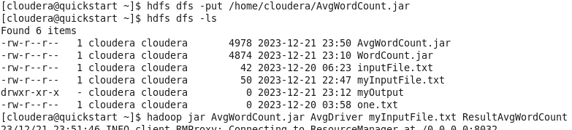

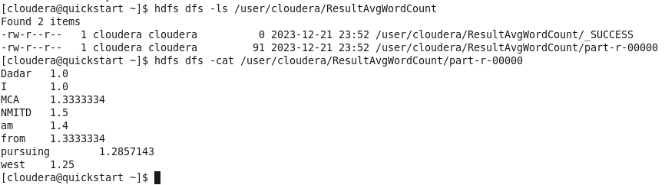

**3. Write a program in Map Reduce to demonstrate sorting operation**.

Step 1: Open virtual box and then start cloudera quickstart

Step 2: Open eclipse present on the cloudera desktop

Step 3: Create java project

File->New-> Java Project

Give project name: MatrixMultiplication

Click Next

Step 4: Add Hadoop libraries to project

Select Libraries tab->click on Add Externa Jars

File System->user->lib->Hadoop

Select all library(jar) files->ok

Again click on Add Externa Jars

File System->user->lib->Hadoop->client

Select all library(jar) files from client->ok->finish

Step 5: Write java code for Sorting using mapreduce

Right click on src folder of project Sorting

New->class

Write class name TestDriver

Click Finish

Write the code for TestDriver

Same way create classes TestMapper and TestReducer

Step 6: Export the project as jar

Right click on project Sorting and select Export>> Java>>JAR file>>Next

Select the export destination-Click browse-give file name Sorting.jar Click ok>>Finish>>ok

Verify the jar file

Verify the jar file through command line open terminal give command

**ls**

step 7: Move the jar file to the Hadoop file system

**hdfs dfs -put Sorting.jar /user/cloudera**

**hdfs dfs -ls**

Step 8: Create the input file for the MapReduce program

Step 9: Move input files into it.

**hdfs dfs -put amazon-orders.txt /user/cloudera/matrixInput/**

**hdfs dfs -ls**

step 10: Run mapreduce program on Hadoop

syntax: hadoop jar jarfilename.jar classname inputfoldername outputfoldername

command: **hadoop jar Sorting.jar SortingDriver amazon-orders.txt ResultSorting**

step 11: view output directory

**hdfs dfs –ls**

**hdfs dfs -ls /user/cloudera/ResultSorting**

step 12: view the output file

## **hdfs dfs -cat /user/cloudera/ResultSorting/part-r-00000**

## TestDriver.java

import org.apache.hadoop.fs.Path;

import org.apache.hadoop.io.IntWritable; import org.apache.hadoop.io.Text;

import org.apache.hadoop.mapreduce.lib.input.FileInputFormat;

import org.apache.hadoop.mapreduce.lib.output.FileOutputFormat; import org.apache.hadoop.mapreduce.Job;

public class TestDriver {

public static void main(String[] args) throws Exception { if (args.length != 2) {

System.out.printf("Usage: WordCount <input dir><output dir>\n");

System.exit(-1);

}

Job job = new Job();

job.setJarByClass(testdriver.class); job.setJobName("Word Count");

FileInputFormat.setInputPaths(job, new Path(args[0])); FileOutputFormat.setOutputPath(job, new Path(args[1]));

job.setMapperClass(testmap.class);

job.setReducerClass(testreduce.class);

job.setMapOutputKeyClass(IntWritable.class);

job.setMapOutputValueClass(IntWritable.class);

job.setOutputKeyClass(IntWritable.class);

job.setOutputValueClass(IntWritable.class);

boolean success = job.waitForCompletion(true); System.exit(success ? 0 : 1);

}

}

## TestMap.java

import java.io.IOException;

import org.apache.hadoop.io.IntWritable; import org.apache.hadoop.io.LongWritable; import org.apache.hadoop.io.Text;

import org.apache.hadoop.mapreduce.Mapper;

public class TestMap extends Mapper<LongWritable, Text, IntWritable, IntWritable> {

@Override

public void map(LongWritable key, Text value, Context context) throws IOException, InterruptedException {

String line = value.toString();

String[] tokens = line.split(","); // This is the delimiter between

int keypart = Integer.parseInt(tokens[0]);

int valuePart = Integer.parseInt(tokens[1]); context.write(new IntWritable(valuePart), new

IntWritable(keypart));

}

}

## TestReduce.java

import java.io.IOException;

import org.apache.hadoop.io.IntWritable;

import org.apache.hadoop.mapreduce.Reducer;

public class TestReduce extends Reducer<IntWritable, IntWritable, IntWritable, IntWritable> {

@Override

public void reduce(IntWritable key, Iterable<IntWritable> values, Context context)

throws IOException, InterruptedException {

for (IntWritable value : values) { context.write(value, key);

}

}

}

## Command:

hadoop jar Sorting.jar TestDriver amazon-orders.txt ResultSorting

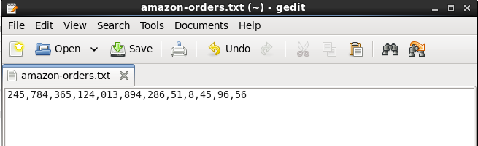



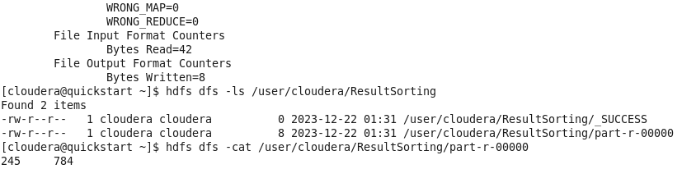

4. Write a program in Map Reduce for Matrix Multiplication

Step 1: Open virtual box and then start cloudera quickstart

Step 2: Open eclipse present on the cloudera desktop

Step 3: Create java project

File->New-> Java Project

Give project name: MatrixMultiplication

Click Next

Step 4: Add Hadoop libraries to project

Select Libraries tab->click on Add Externa Jars

File System->user->lib->Hadoop

Select all library(jar) files->ok

Again click on Add Externa Jars

File System->user->lib->Hadoop->client

Select all library(jar) files from client->ok->finish

Step 5: Write java code for matrix multiplication using mapreduce

Right click on src folder of project MatrixMultiplication

New->class

Write class name MatrixMultiplicationDriver

Click Finish

Write the code for MatrixMultiplicationDriver

Same way create classes MatrixMultiplicationMapper and MatrixMultiplicationReducer

Step 6: Export the project as jar

Right click on project MatrixMultiplication and select Export>> Java>>JAR file>>Next

Select the export destination-Click browse-give file name matrixmultiplication.jar Click ok>>Finish>>ok

Verify the jar file

Verify the jar file through command line open terminal give command

**ls**

step 7: Move the jar file to the Hadoop file system

**hdfs dfs -put matrixmultiplication.jar /user/cloudera**

**hdfs dfs -ls**

Step 8: Create the input file for the MapReduce program

First input file

Command: **cat > myMMmatrix.txt**

Enter data in input file

M,0,0,1

M,0,1,2

M,1,0,3

M,1,1,4

and press enter and ctrl z

Command: **cat myMMmatrix.txt**

Second input file

Command: **cat > myNMatrix.txt**

Enter data in input file

N,0,0,3

N,0,1,6

N,1,0,4

N,1,1,2

and press enter and ctrl z

Command: **cat myNMatrix.txt**

Step 9: Create the input directory and move input files into it.

**hdfs dfs –mkdir /user/cloudera/matrixinput**

**hdfs dfs -put myMMmatrix.txt /user/cloudera/matrixInput/**

**hdfs dfs -put myNMmatrix.txt /user/cloudera/matrixInput/**

**hdfs dfs -ls**

step 10: Run mapreduce program on Hadoop

syntax: hadoop jar jarfilename.jar classname inputfoldername outputfoldername

command: **hadoop jar matrixmultiplication.jar MatrixMultiplicationDriver matrixInput matrixOutput**

step 11: view output directory

**hdfs dfs –ls**

**hdfs dfs -ls /user/cloudera/matrixOutput**

step 12: view the output file

**hdfs dfs -cat /user/cloudera/matrixOutput/part-r-00000**

**MatrixMultiplicationDriver.java**

import org.apache.hadoop.conf.*;

import org.apache.hadoop.fs.Path;

import org.apache.hadoop.io.*;

import org.apache.hadoop.mapreduce.*;

import org.apache.hadoop.mapreduce.lib.input.FileInputFormat;

import org.apache.hadoop.mapreduce.lib.input.TextInputFormat;

import org.apache.hadoop.mapreduce.lib.output.FileOutputFormat;

import org.apache.hadoop.mapreduce.lib.output.TextOutputFormat;

public class MatrixMultiplicationDriver {

public static void main(String[] args) throws Exception{

// TODO Auto-generated method stub

if (args.length != 2) {

System.err.println("Usage: MatrixMultiply <in_dir> <out_dir>"); System.exit(2);

}

Configuration conf = new Configuration();

// M is an m-by-n matrix; N is an n-by-p matrix.

conf.set("m", "1000");

conf.set("n", "100");

conf.set("p", "1000");

Job job = new Job(conf, "MatrixMultiply");

job.setJarByClass(MMDriver.class);

job.setOutputKeyClass(Text.class);

job.setOutputValueClass(Text.class);

job.setMapperClass(MMMapper.class);

job.setReducerClass(MMReducer.class);

job.setInputFormatClass(TextInputFormat.class);

job.setOutputFormatClass(TextOutputFormat.class);

FileInputFormat.addInputPath(job, new Path(args[0]));

FileOutputFormat.setOutputPath(job, new Path(args[1]));

job.waitForCompletion(true);

}

}

**MatrixMultiplicationMapper.java**

import java.io.IOException;

import org.apache.hadoop.conf.*;

import org.apache.hadoop.io.LongWritable;

import org.apache.hadoop.io.Text;

import org.apache.hadoop.mapreduce.Mapper;

public class MatrixMultiplicationMapper extends Mapper<LongWritable, Text, Text, Text>{

@Override

public void map(LongWritable key, Text value, Context context) throws IOException, InterruptedException {

Configuration conf = context.getConfiguration();

int m = Integer.parseInt(conf.get("m"));

int p = Integer.parseInt(conf.get("p"));

String line = value.toString();

// (M, i, j, Mij);

String[] indicesAndValue = line.split(",");

Text outputKey = new Text();

Text outputValue = new Text();

if (indicesAndValue[0].equals("M")) {

for (int k = 0; k < p; k++) {

outputKey.set(indicesAndValue[1] + "," + k); // outputKey.set(i,k);

outputValue.set(indicesAndValue[0] + "," + indicesAndValue[2]

+ "," + indicesAndValue[3]); // outputValue.set(M,j,Mij);

context.write(outputKey, outputValue);

}

} else {

// (N, j, k, Njk);

for (int i = 0; i < m; i++) {

outputKey.set(i + "," + indicesAndValue[2]);

outputValue.set("N," + indicesAndValue[1] + ","

+ indicesAndValue[3]);

context.write(outputKey, outputValue);

}

}

}

}

**MatrixMultiplicationReducer.java**

import org.apache.hadoop.io.Text;

import java.io.IOException;

import java.util.HashMap;

public class MatrixMultiplicationReducer extends org.apache.hadoop.mapreduce.Reducer<Text, Text, Text, Text>{

@Override

public void reduce(Text key, Iterable<Text> values, Context context)

throws IOException, InterruptedException {

String[] value;

//key=(i,k),

//Values = [(M/N,j,V/W),..]

HashMap<Integer, Float> hashA = new HashMap<Integer, Float>();

HashMap<Integer, Float> hashB = new HashMap<Integer, Float>();

for (Text val : values) {

value = val.toString().split(",");

if (value[0].equals("M")) {

hashA.put(Integer.parseInt(value[1]), Float.parseFloat(value[2]));

} else {

hashB.put(Integer.parseInt(value[1]), Float.parseFloat(value[2]));

}

}

int n = Integer.parseInt(context.getConfiguration().get("n"));

float result = 0.0f;

float m_ij;

float n_jk;

for (int j = 0; j < n; j++) {

m_ij = hashA.containsKey(j) ? hashA.get(j) : 0.0f;

n_jk = hashB.containsKey(j) ? hashB.get(j) : 0.0f;

result += m_ij * n_jk;

}

if (result != 0.0f) {

context.write(null,

new Text(key.toString() + "," + Float.toString(result)));

}

}

}

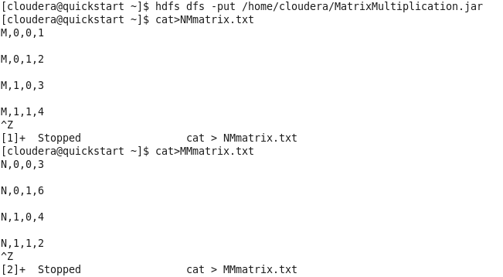



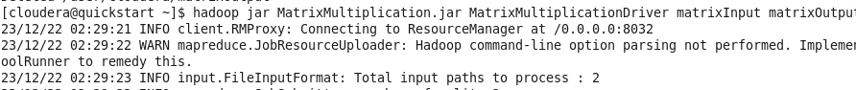

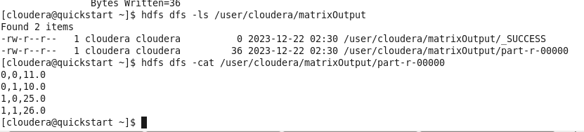

**Practical 3**

#### MongoDB –

MongoDB is a document-oriented NoSQL database used for high volume data storage. Instead of using tables and rows as in the traditional relational databases, MongoDB makes use of collections and documents. Documents consist of key-value pairs which are the basic unit of data in MongoDB. Collections contain sets of documents and function which is the equivalent of relational database tables. MongoDB is a database which came into light around the mid- 2000s.

**MongoDB Features -**

1. Each database contains collections which in turn contains documents. Each document can be different with a varying number of fields. The size and content of each document can be different from each other.
2. The document structure is more in line with how developers construct their classes and objects in their respective programming languages. Developers will often say thattheir classes are not rows and columns but have a clear structure with key-value pairs.
3. The rows (or documents as called in MongoDB) doesn’t need to have a schema defined beforehand. Instead, the fields can be created on the fly.
4. The data model available within MongoDB allows you to represent hierarchical relationships, to store arrays, and other more complex structures more easily.
5. Scalability – The MongoDB environments are very scalable. Companies across the world have defined clusters with some of them running 100+ nodes with around millions of documents within the database

1. Installation

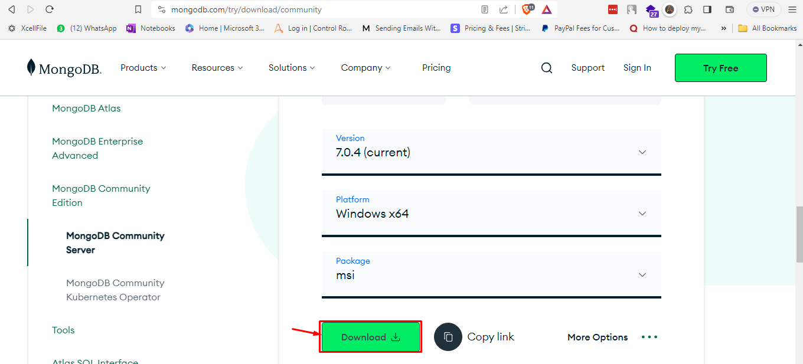

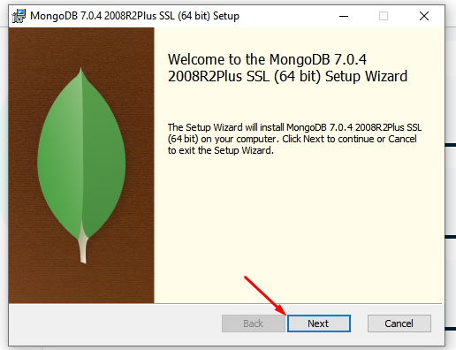

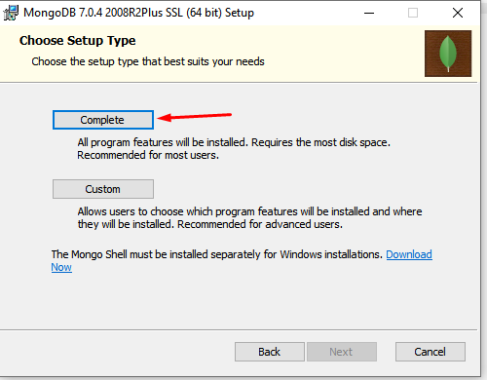

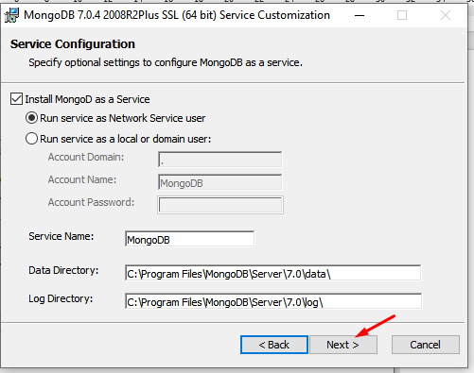

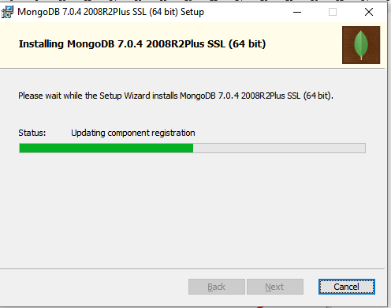

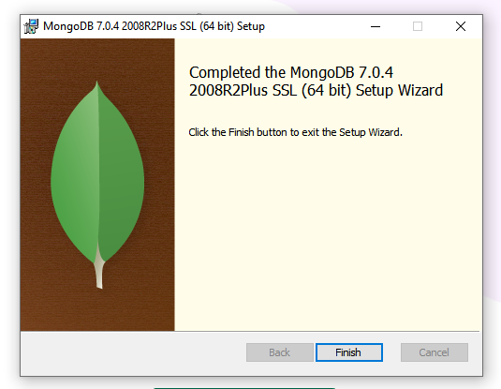

2. Sample Database Creation

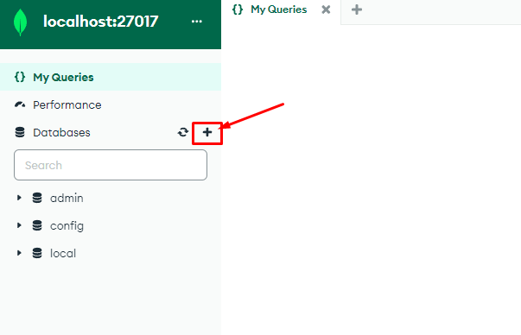

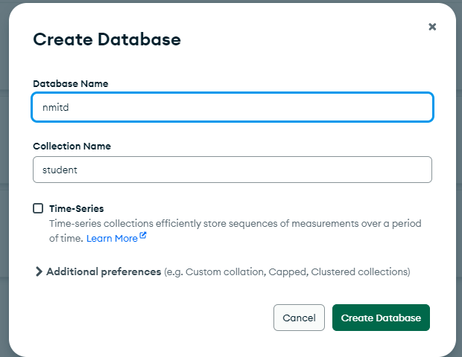

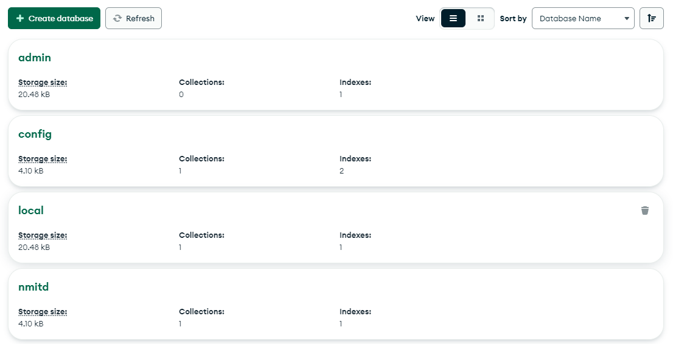

3. Query the Sample Database using MongoDB querying commands

a. Create Collection

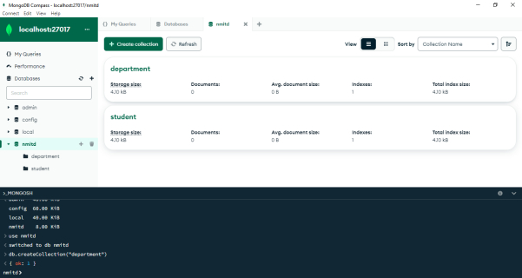

b. Insert Document

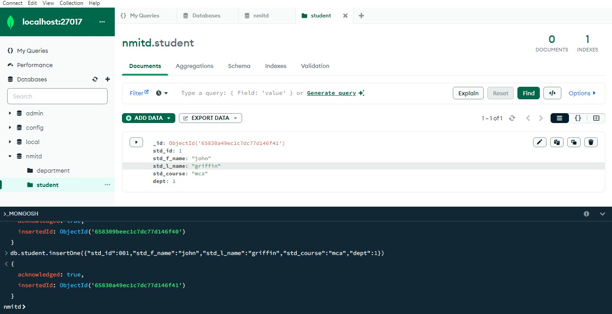

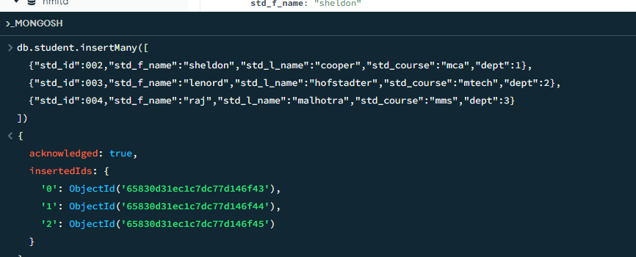

c. Query Document

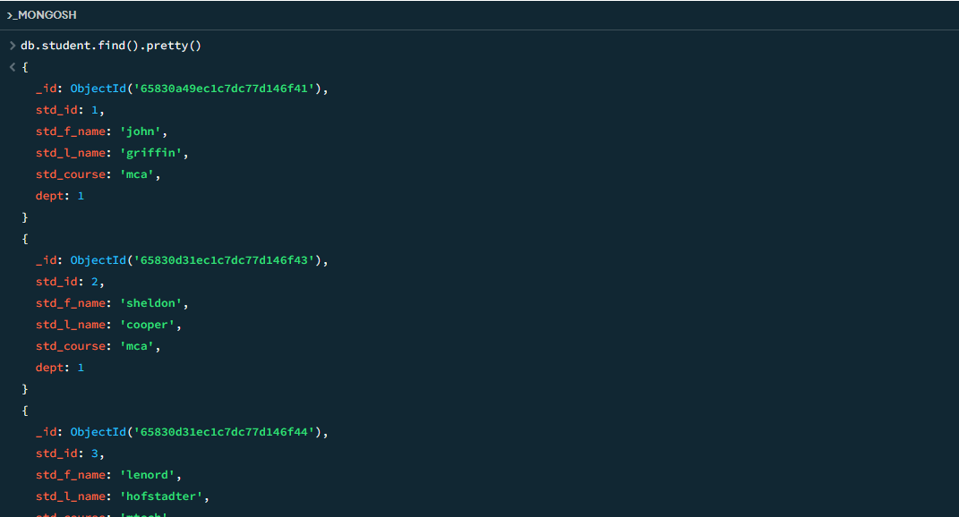

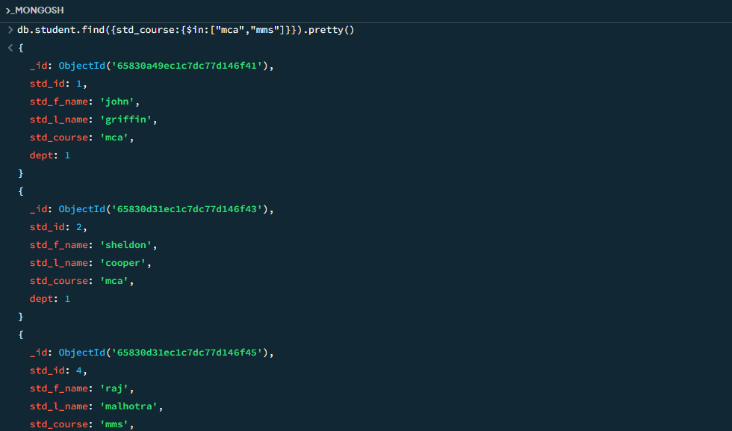

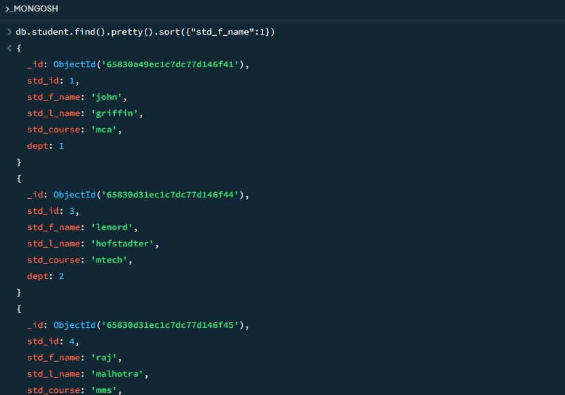

d. Delete Document

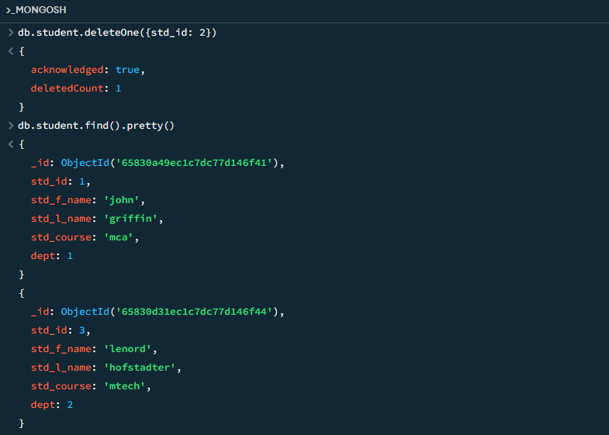

e. Indexing

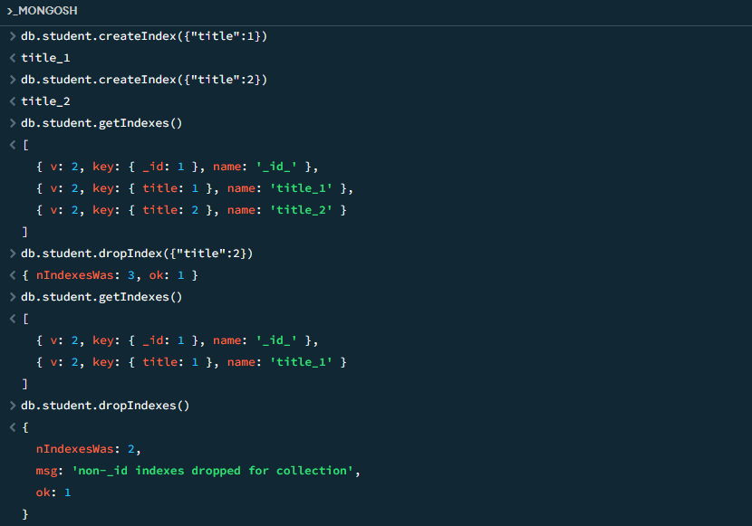

**Practical 4**

**Introduction to hive:**

* Hive is a data warehouse infrastructure tool to process structured data in Hadoop. It resides on top of Hadoop to summarize Big Data, and makes querying and analyzing easy.
* Initially Hive was developed by Facebook, later the Apache Software Foundation took it up and developed it further as an open source under the name Apache Hive. It is used by different companies. For example, Amazon uses it in Amazon Elastic MapReduce.
* Using Hive, we can skip the requirement of the traditional approach of writing complex MapReduce programs. Hive supports Data Definition Language (DDL), Data Manipulation Language (DML), and User Defined Functions (UDF).

#### Hive is not:

* A relational database.
* A design for Online Transaction Processing (OLTP). A language for real-time queries and row-level updates. Hive is not capable of handling real-time data.
* It is not designed for online transaction processing. Hive queries contain high latency.

#### o Features of Hive:

* Hive is fast and scalable.
* It provides SQL-like queries (i.e., HQL) that are implicitly transformed to MapReduce or Spark jobs.
* It is capable of analyzing large datasets stored in HDFS.
* It allows different storage types such as plain text, RCFile, and HBase. It uses indexing to accelerate queries.
* It can operate on compressed data stored in the Hadoop ecosystem.
* It supports user-defined functions (UDFs) where user can provide its functionality.

1. Hive Data Types

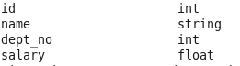

1. Create Database & Table in Hive

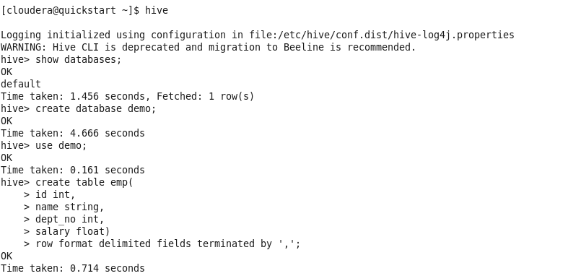

1. Hive Partitioning

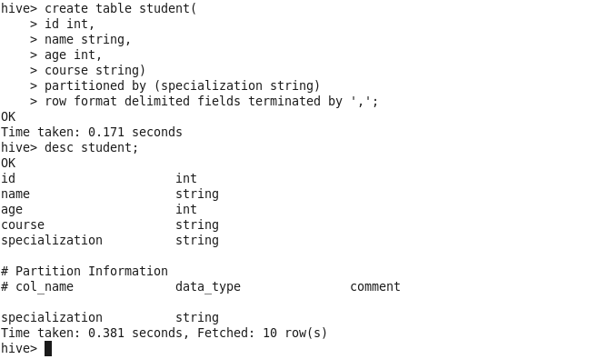

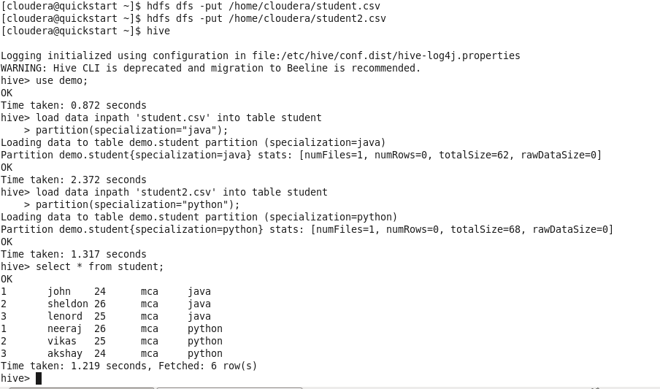

1. Hive Built-In Operators

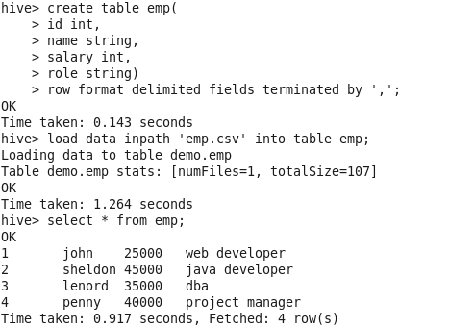

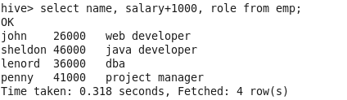

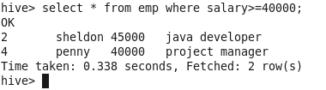

1. Hive Built-In Functions

sqrt()

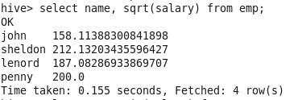

min()



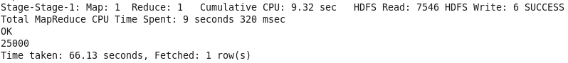

max()



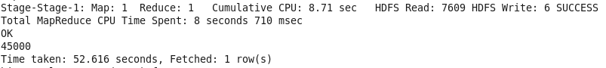

upper()

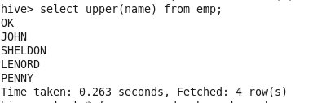

6. Hive Views and Indexes

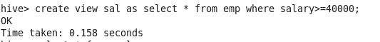

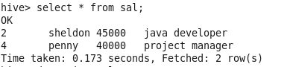

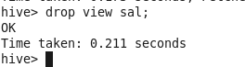

**Order by**



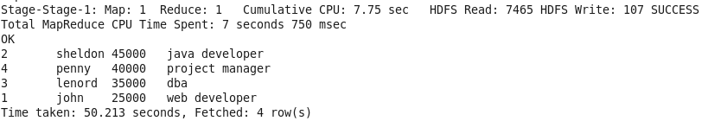

**Group By**



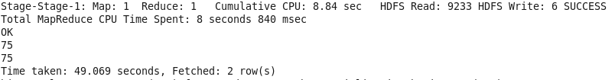

**Join**



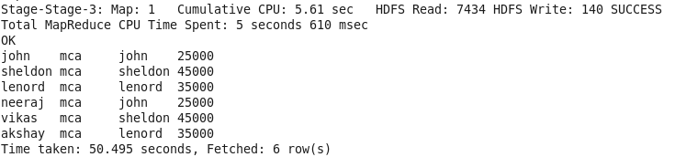

**Views**

Create



Display View

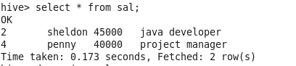

**Index**

Create



Show Index



Drop Index

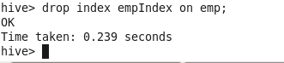

**Practical 5**

The language used to analyze data in Hadoop using Pig is known as Pig Latin. It is a highlevel data processing language which provides a rich set of data types and operators to perform various operations on the data.

To perform a particular task Programmers using Pig, programmers need to write a Pig script using the Pig Latin language and execute them using any of the execution mechanisms (Grunt Shell, UDFs, Embedded). After execution, these scripts will go through a series of transformations applied by the Pig Framework, to produce the desired output.

Internally, Apache Pig converts these scripts into a series of MapReduce jobs, and thus, it

makes the programmer’s job easy.

Case Sensitivity

Keywords in Pig Latin are not case-sensitive; for example, LOAD is equivalent to load. But relation and field names are, so A = load 'foo'; is not equivalent to a = load 'foo';. UDF names are also case-sensitive; thus, COUNT is not the same UDF as count.

Apache Pig Components

As shown in the figure, there are various components in the Apache Pig framework. Let us take a look at the major components.

Parser

Initially the Pig Scripts are handled by the Parser. It checks the syntax of the script, does type checking, and other miscellaneous checks. The output of the parser will be a DAG (directed acyclic graph), which represents the Pig Latin statements and logical operators.

In the DAG, the logical operators of the script are represented as the nodes and the data flowsare represented as edges.

Optimizer

The logical plan (DAG) is passed to the logical optimizer, which carries out the logical optimizations such as projection and pushdown.

Compiler

The compiler compiles the optimized logical plan into a series of MapReduce jobs. Execution engine

Finally the MapReduce jobs are submitted to Hadoop in a sorted order. Finally, these



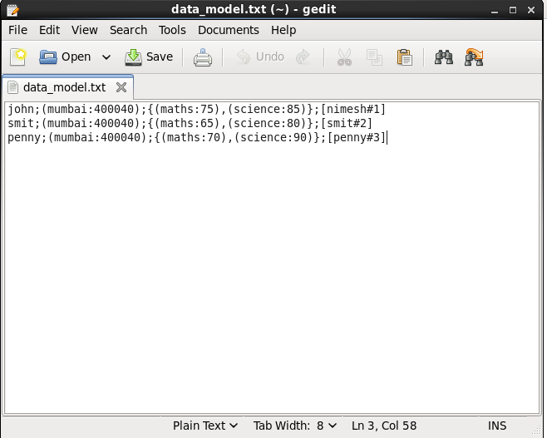



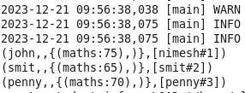

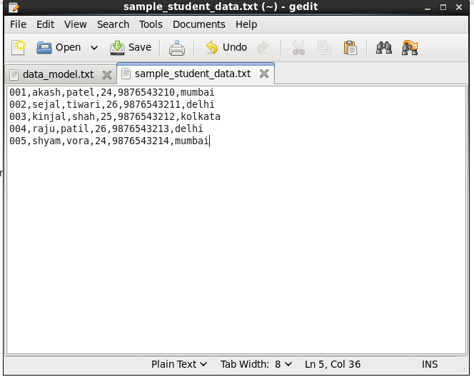



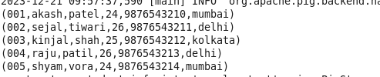



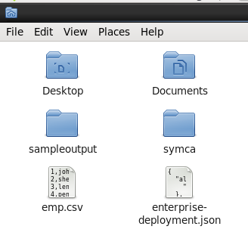 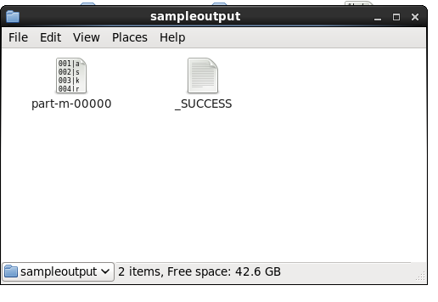

Pig Operations

Describe

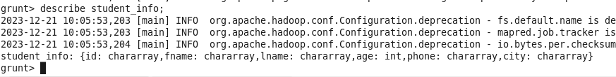

Filter



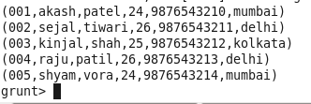

Explain

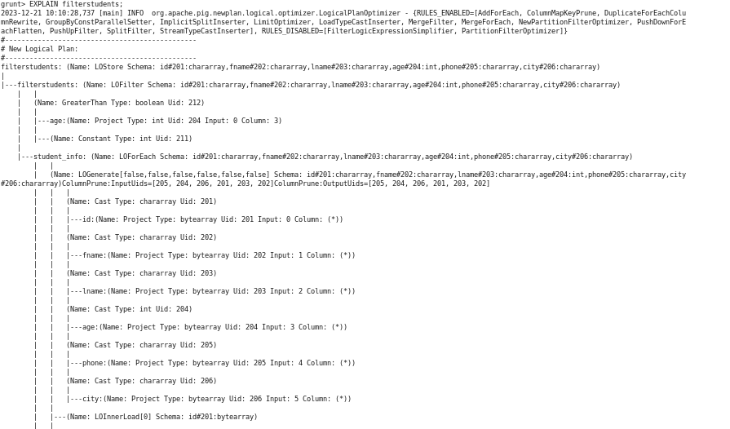

ForEach



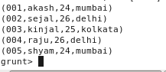

Group



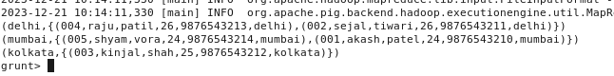

Illustrate



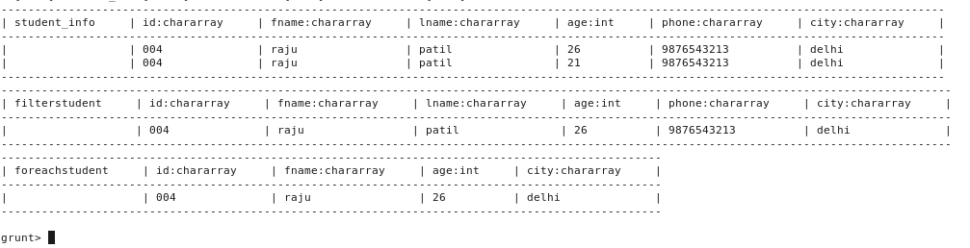

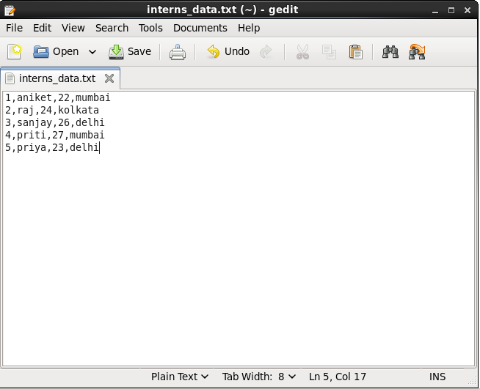



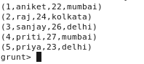

COGroup



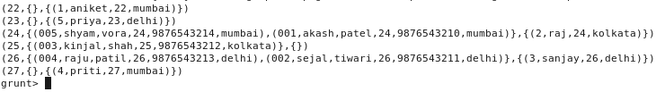

Join



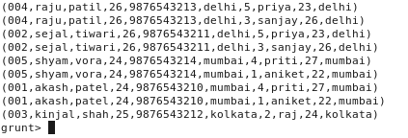

Left join



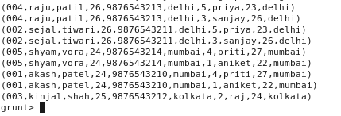

Right join



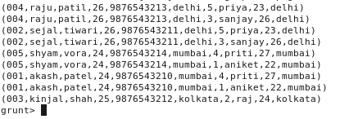

Split



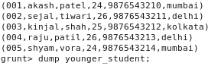

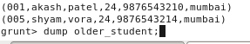

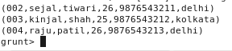

Filter





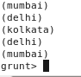

Word Counter

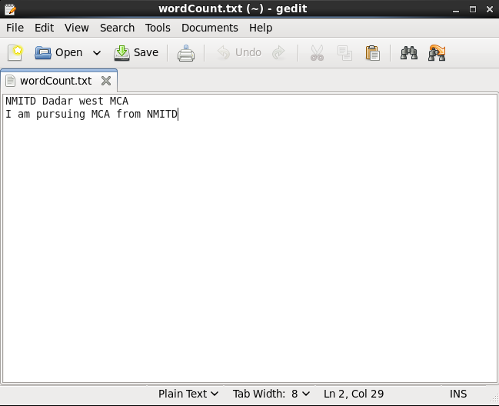

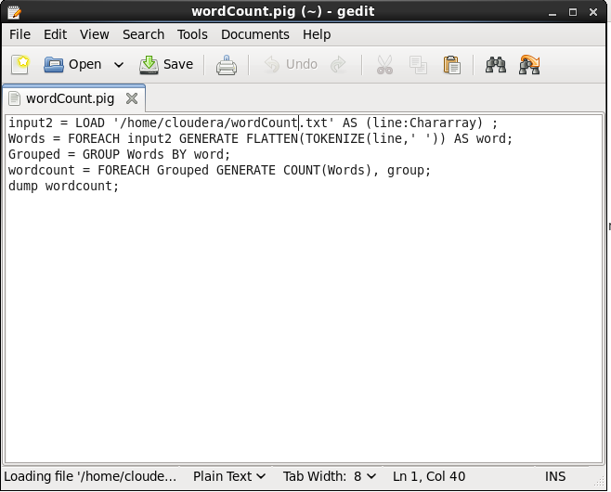

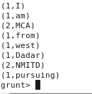

**Practical 6**

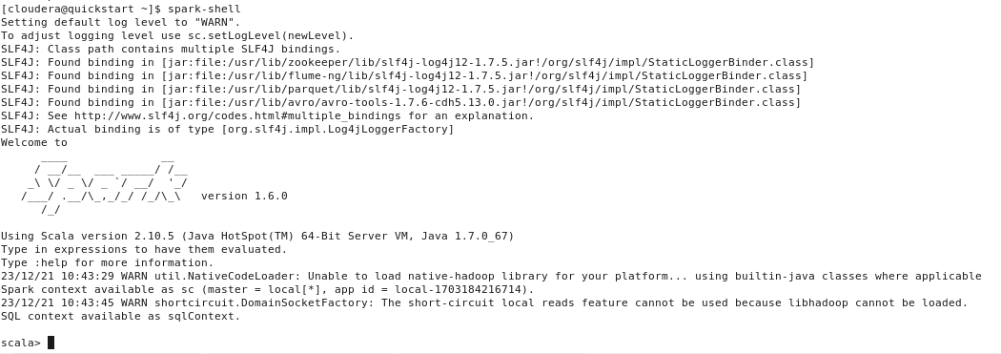

**valdata=sc.parallelize(List(10,20,30))**



data.collect



**:history**

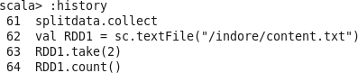

valmapfunc=data.map(x=>x+10



mapfunc.collect



valdata=sc.parallelize(List(20,60,40,100))



**data.collect**



valfilterfunc=data.filter(x=>x!=40)



filterfunc.collect



valcountfunc=data.count()



data.collect



valdistinctfunc=data.distinct()



valdistinctfunc=data.count()



distinctfunc.collect



valdata1=sc.parallelize(List(20,60,40,100,20))



valdistinctfunc=data1.distinct()



scala>distinctfunc.collect



**valdata2= sc.parallelize(List(1,2))**

**data2.collect**

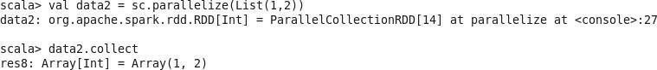

val data3 = sc.parallelize(List(2,3,5))

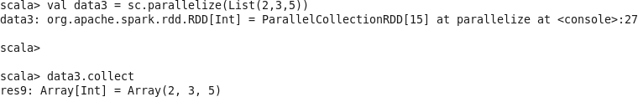

**Valunionfunc = data2.union(data3)**

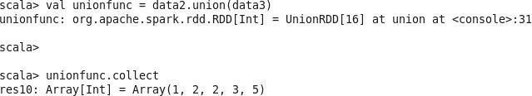

**Valintersectfunc = data2.intersection(data3)**

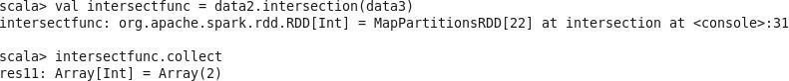

**valcartesianfunc= data2.cartesian(data3)**

data3.collect

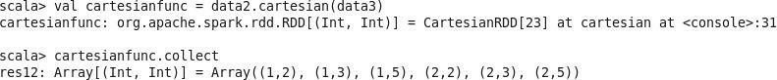

**valdata=sc.parallelize(Seq(("C",3),("A",1),("D",4),("B",2),("E",5))) data.collect**



**valsortfunc= data.sortByKey()**

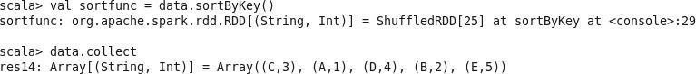

sortfunc.collect

val sortfunc = data.sortByKey(false)

sortfunc.collect

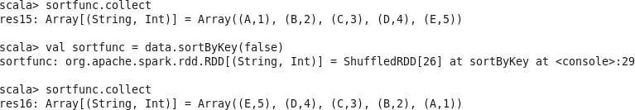

**valgroupfunc= data.groupByKey()**



**valdata=sc.parallelize(Seq(("C",3),("A",1),("D",4),("B",2),("E",5),("B",6)))**

**valgroupfunc= data.groupByKey()**

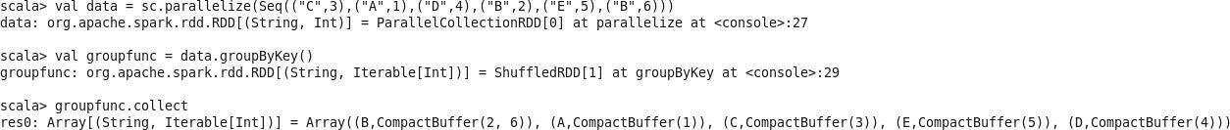

**valreducefunc=data.reduceByKey((value,x)=>(value +x))reducefunc.collect**

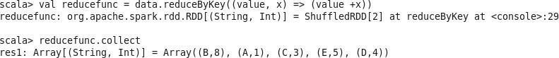

**valdata1=sc.parallelize(Seq(("A",1),("B",2),("C",3)))**

**data1.collect**



**valdata2=sc.parallelize(Seq(("F",6),("E",5),("D",4)))**

**data2.collect**



**valcogroupfunc=data1.cogroup(data2)**

cogroupfunc.collect



**valfirstfunc=data.first()**

**valtakefunc=**

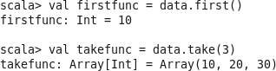

**data2.collect().foreach(print)**

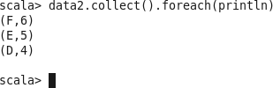

val data = sc.textFile("/indore/content.txt")

data.collect

valsplitdata=data.flatMap(line=>line.split(""));

splitdata.collect

valRDD1=sc.textFile(/indore/content.txt")

• RDD1.take(2)



RDD1.count()



● valsplitdata=RDD1. flatMap(line=>line.split(""))]]];

● • splitdata.collect

● • for(line<-RDD1.take(2))println(line)

● • valmapdata=splitdata.map(word=>(word,1));

● • mapdata.collect()

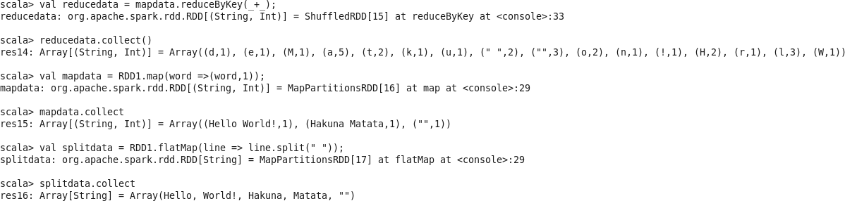

● valreducedata=mapdata.reduceByKey(_+_);

● • reducedata.collect()

● • valmapdata=RDD1.map(word=>(word,1));

● • mapdata.collect

● • valsplitdata=RDD1.flatMap(line=>line.split(""));

● • splitdata.collect

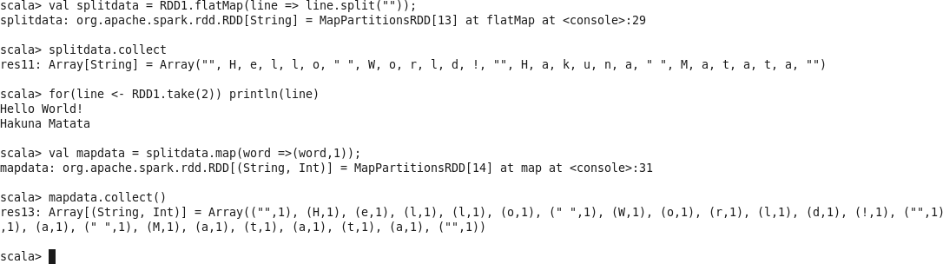

**Practical 7**

Analysis Operations

Q 1: Find the customer with the highest overall profit. What is his/her profit ratio? Ans: Step 1: Open the superstoreus2015 excel data set

Step 2: Drag Orders sheet to sheet area

Step 3: Go to sheet 1 and add Customer name as rows and profit as column

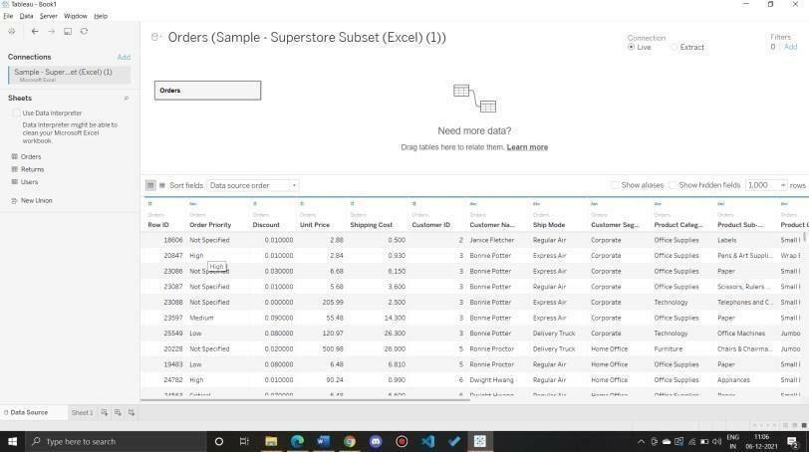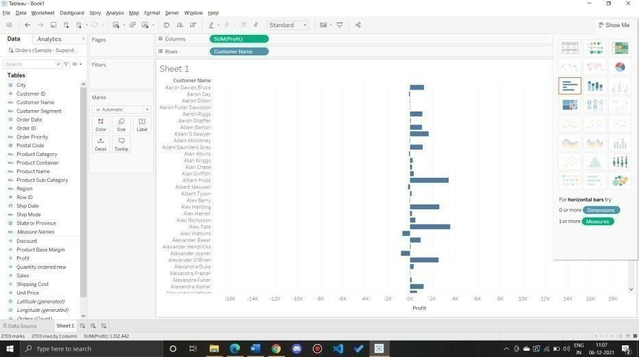

Step 4: Sort the data by clicking on Profit label on bottom

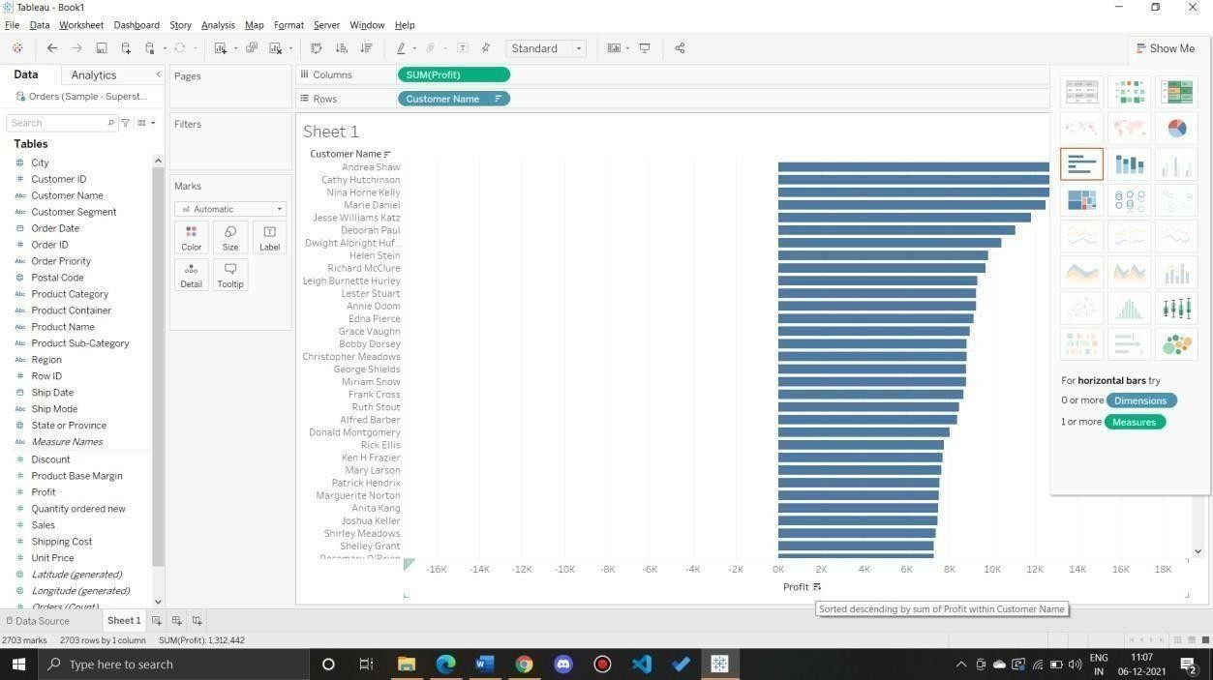

Step 5: To calculate profit Ratio

Profit Ratio= (Sum([Profit])/Sum([Sales]))

This formula needs to be entered as tooltip or label

Click on Analysis>Create Calculated Field and enter the formula

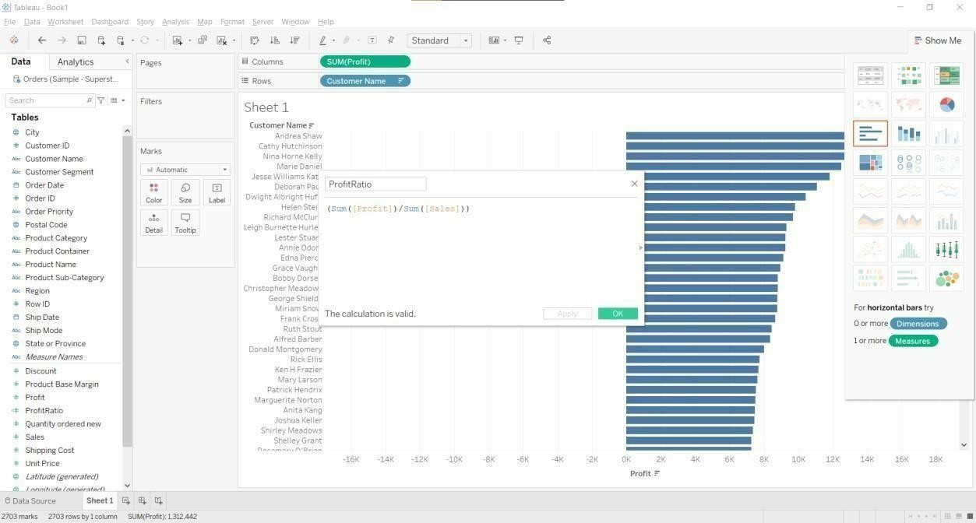

You can see ProfitRatio(Or name you provided) in measures. Drag is to Marks area.

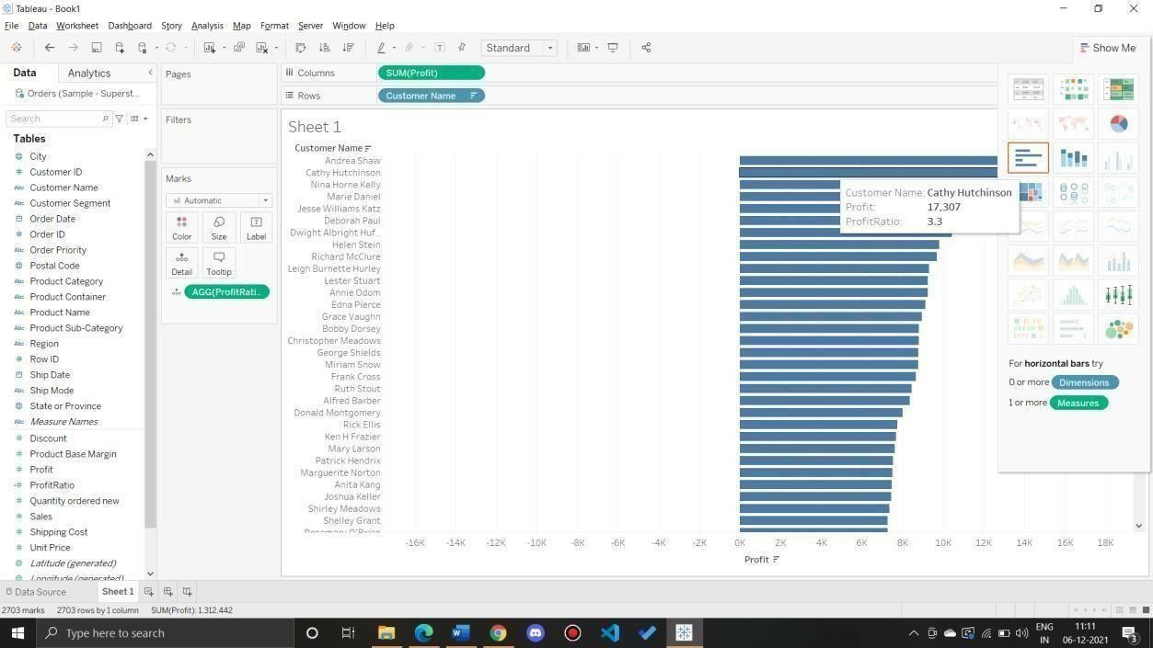

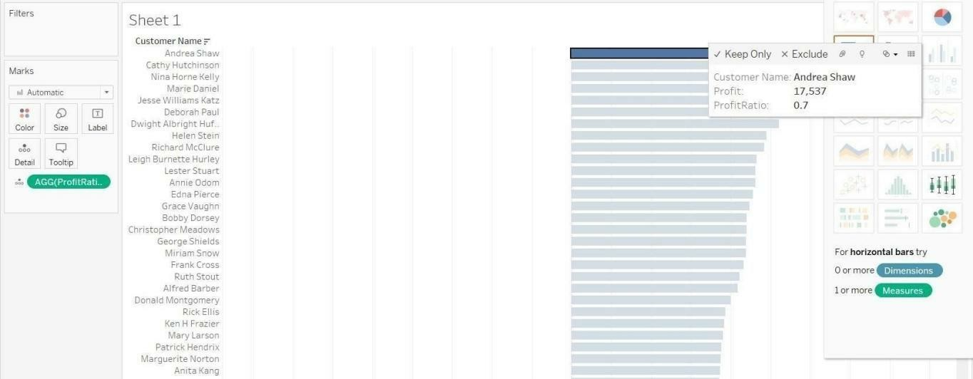

To remove something from column and row

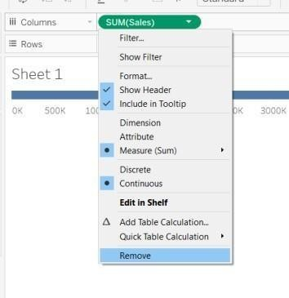

Q2: Which state has the highest Sales (Sum)? What is the total Sales for that state? Ans:

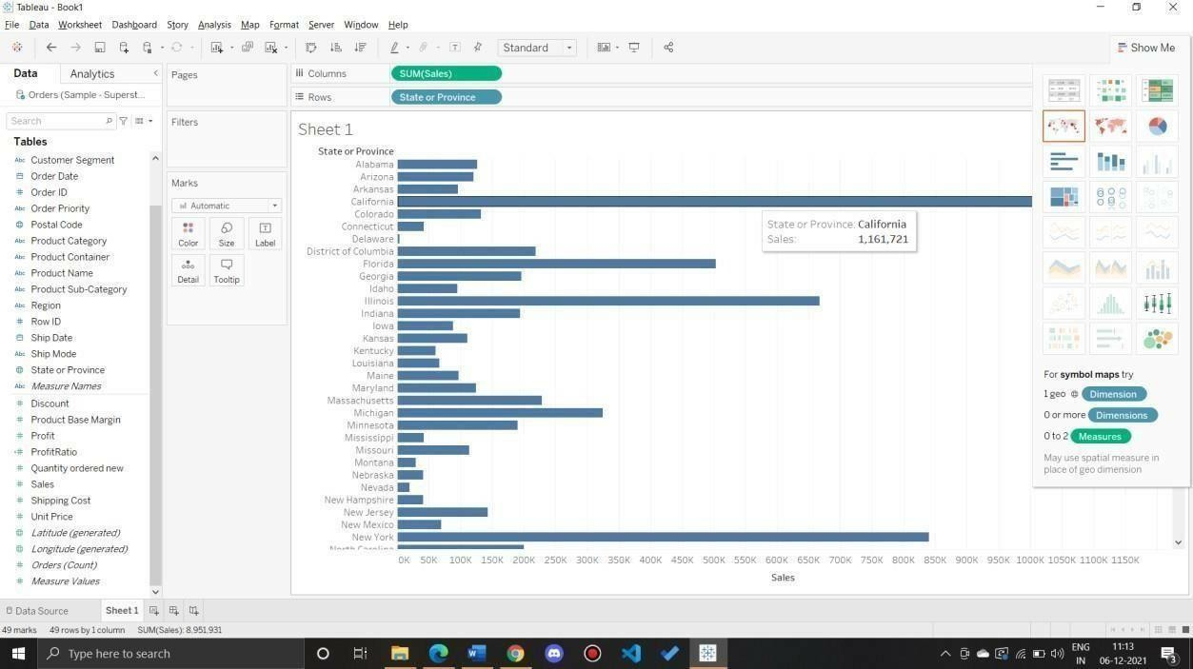

Q 3: Which customer segment has both the highest order quantity and average discount rate? What is the order quantity and average discount rate for that state?

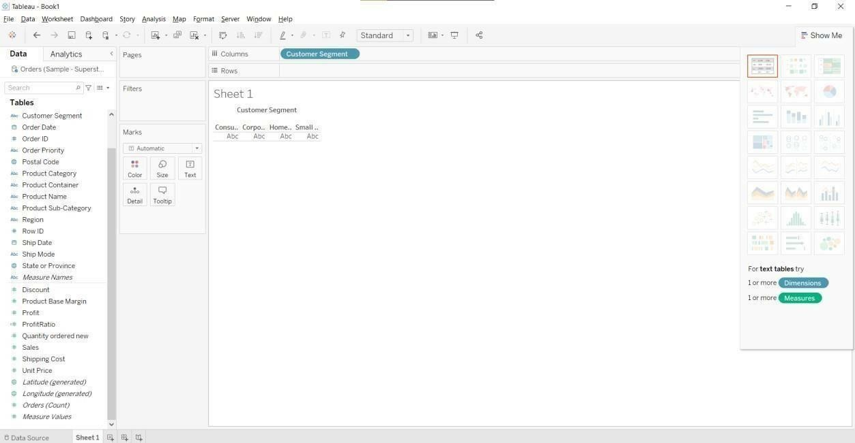

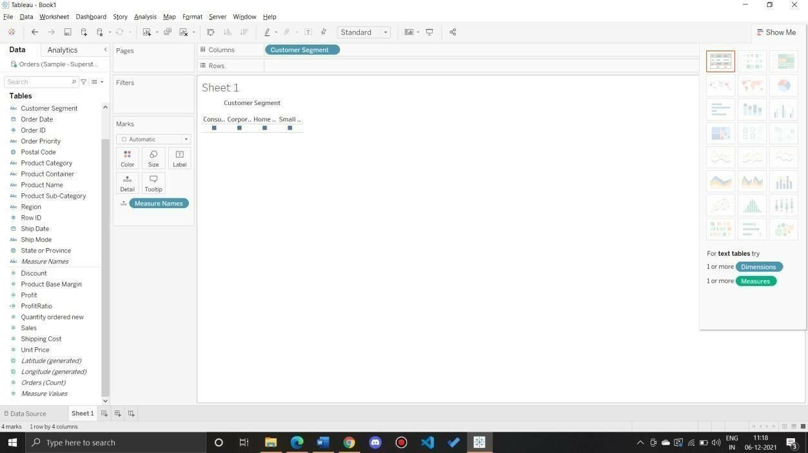

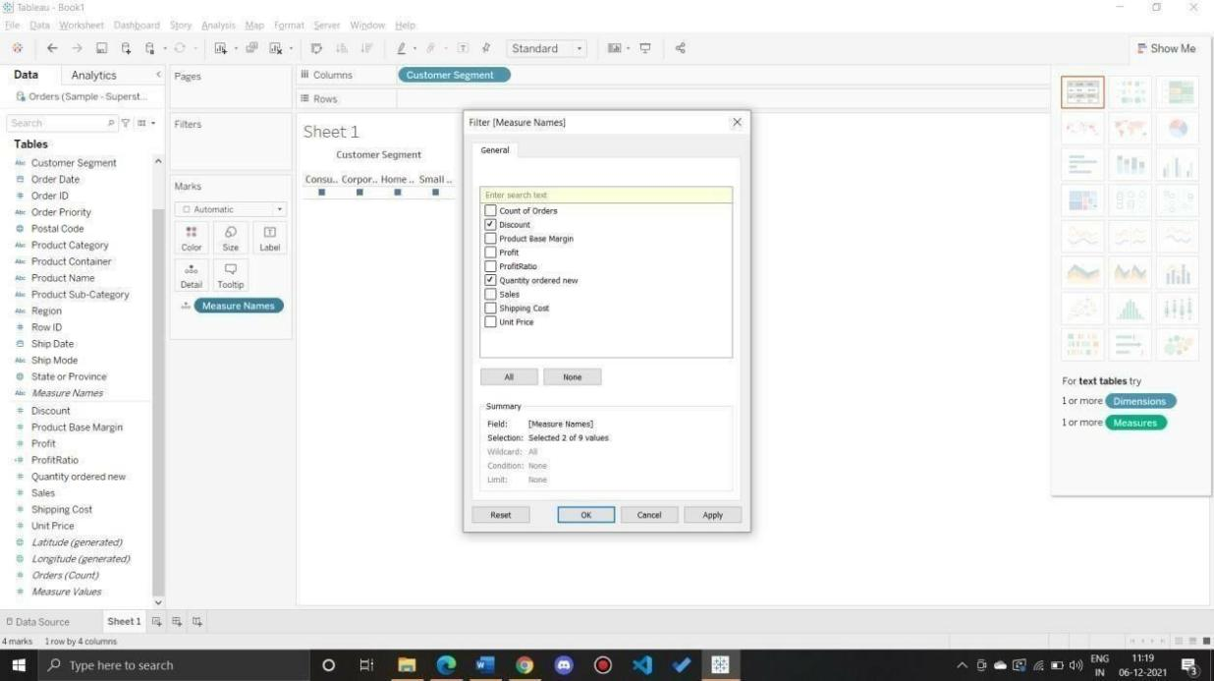

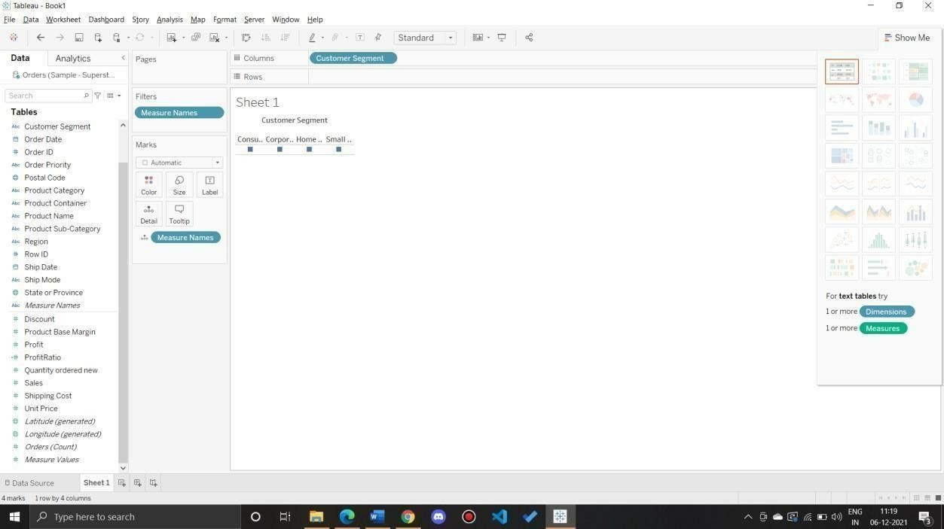

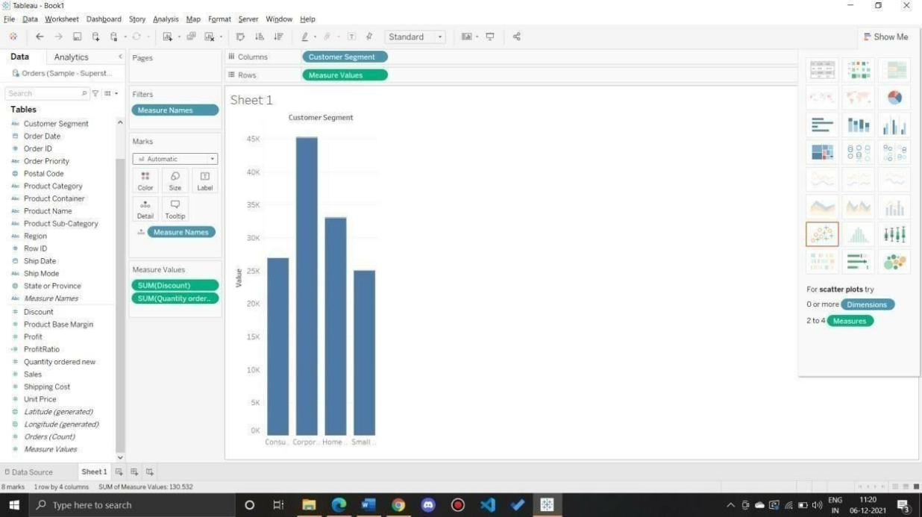

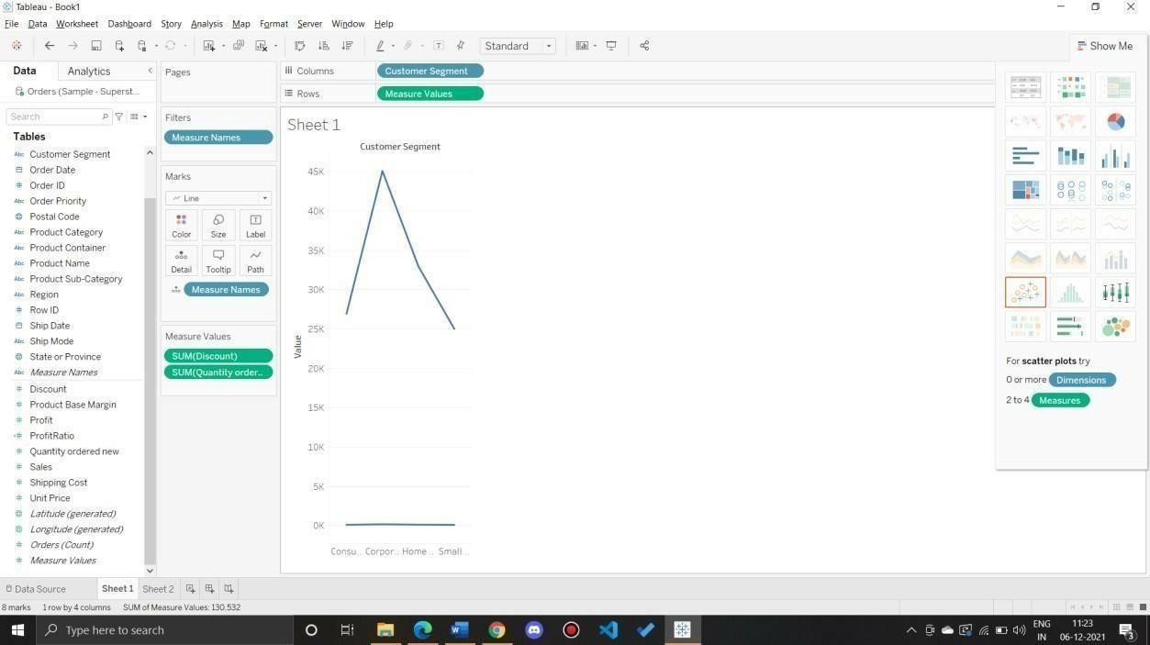

Q 4: Which Product Category has the highest total Sales? Which Product Category has the worst Profit? Name the Product Category and $ amount for each.

Ans:

Bar Chart displaying total Sales for each Product Category

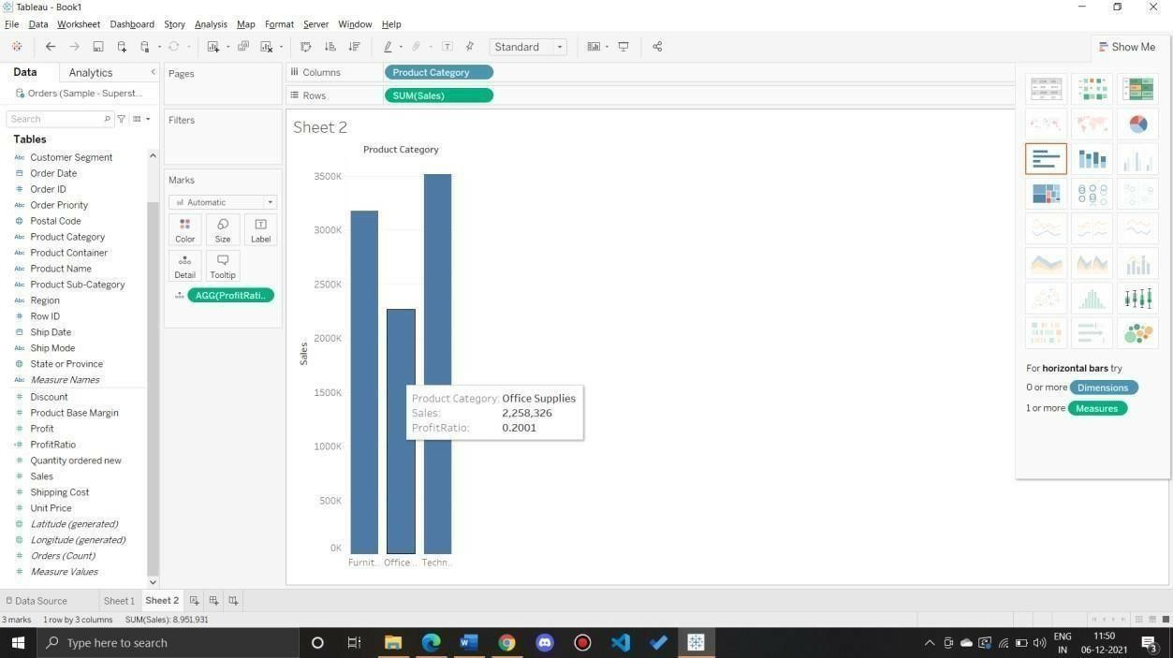

Add a color scale indicating Profit

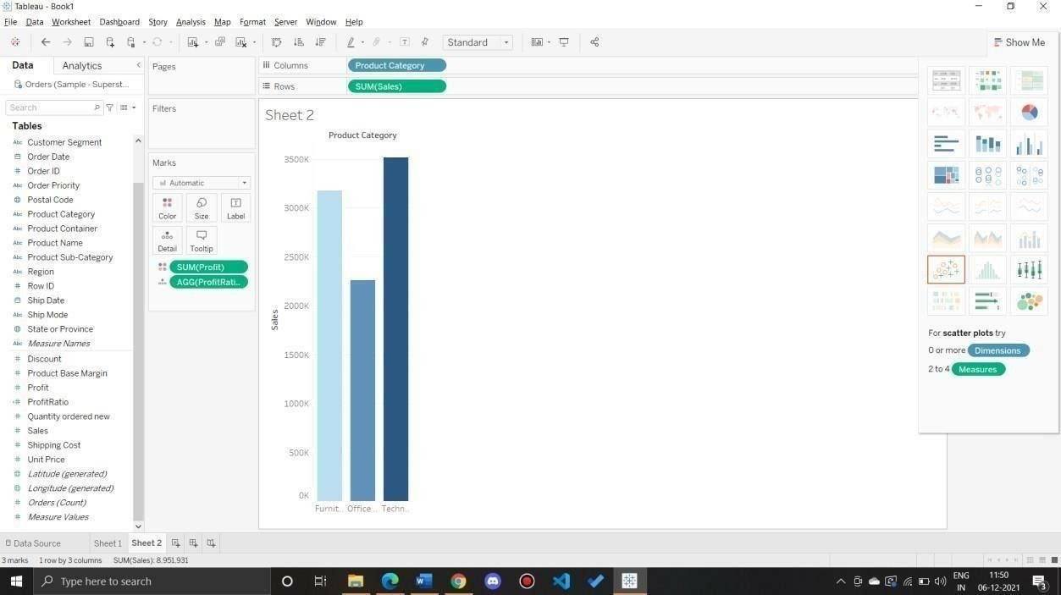

Each Product Category labeled with total Sales and Each Product Category labeled with Profit

Q 5: Use the same visualization created for Question #4.What was the Profit on Technology (Product Category) in Boca Raton (City) ?

Add Filter City

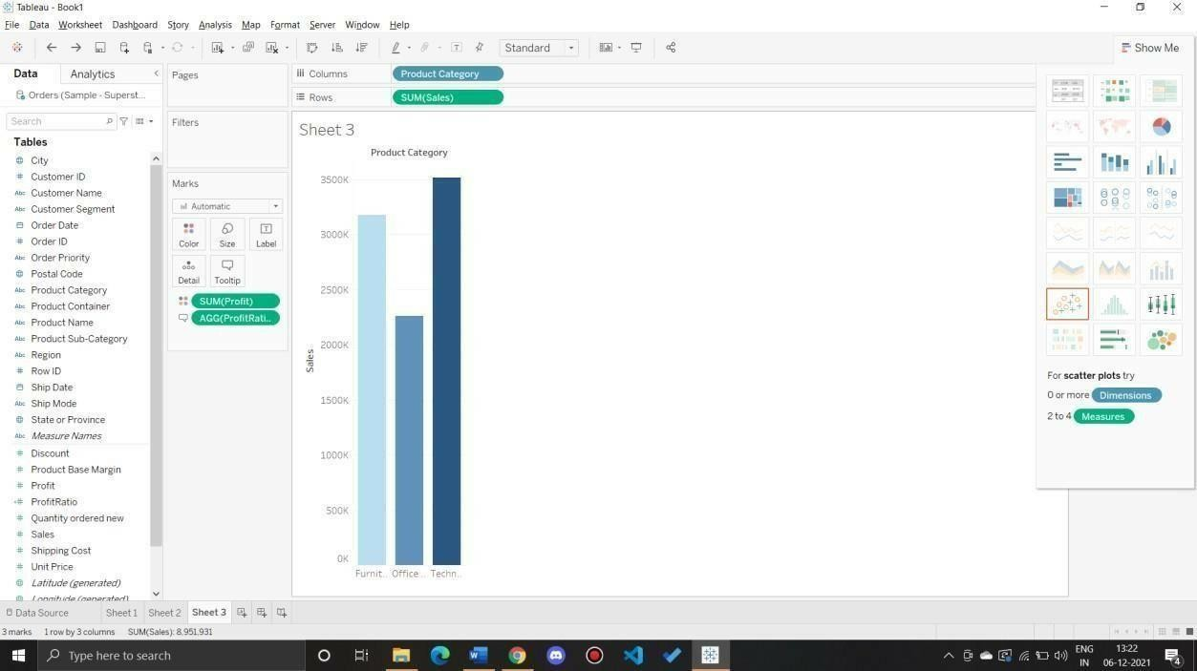

Select the city to show a single bar for the city

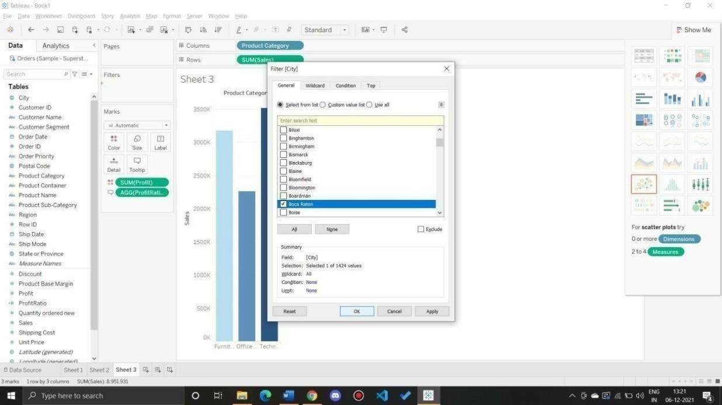

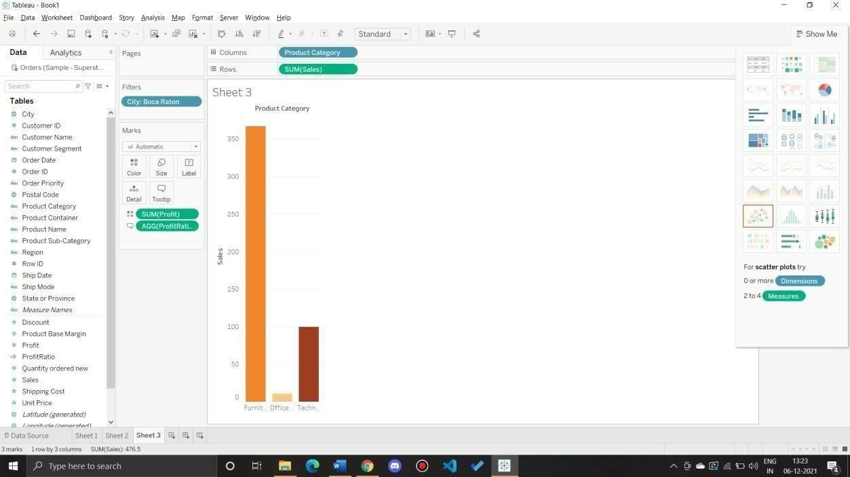

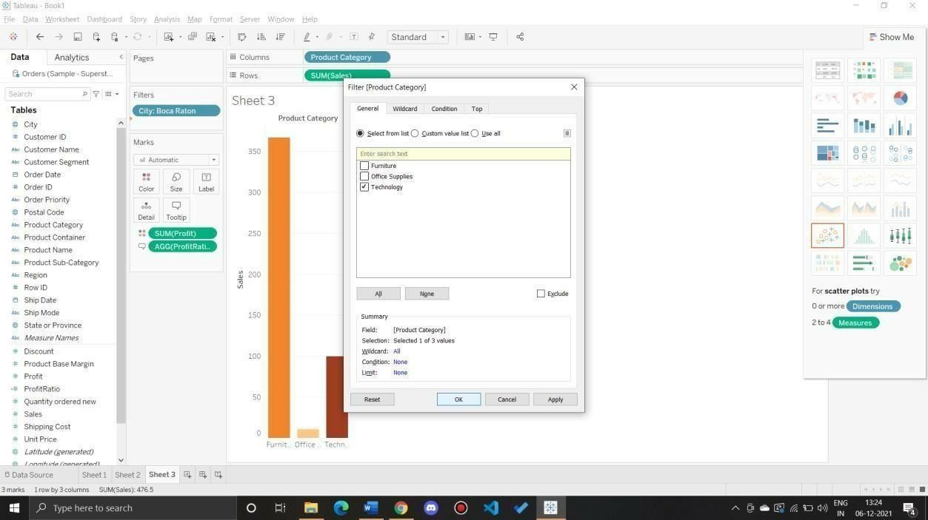

Q 6: Which Product Department has the highest Shipping Costs? Name the Department and cost.

Packed bubble chart showing each Product Department as a colored bubble

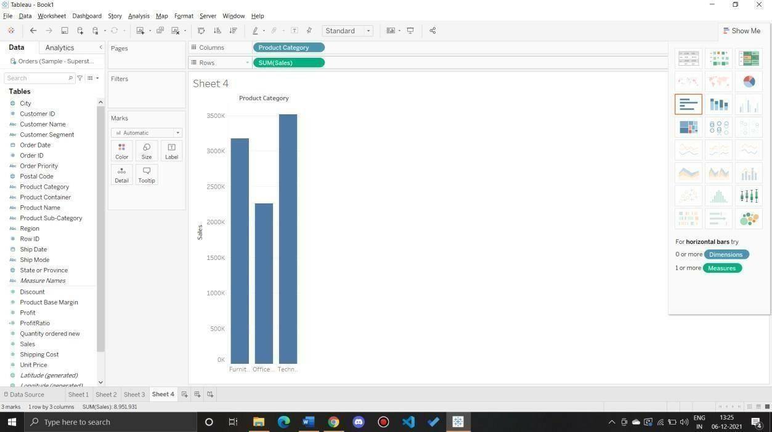

Use Shipping Cost to display the size of each bubble

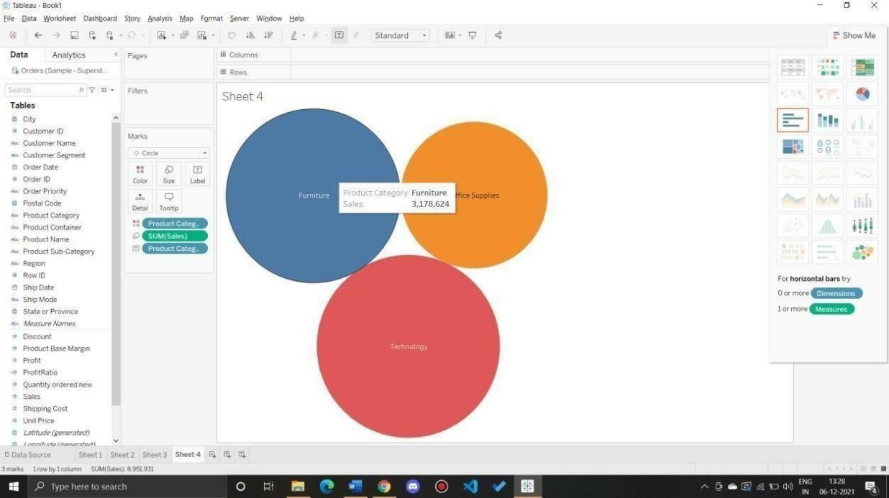

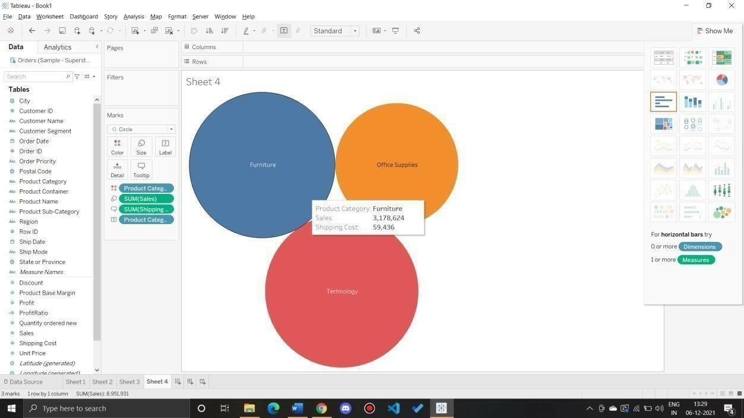

Q 7: Use the same visualization created for Question #6. What was the shipping cost of Office Supplies for Xerox 1905 in the Home Customer Segment in Cambridge?

Ans: Apply filters as per requirement

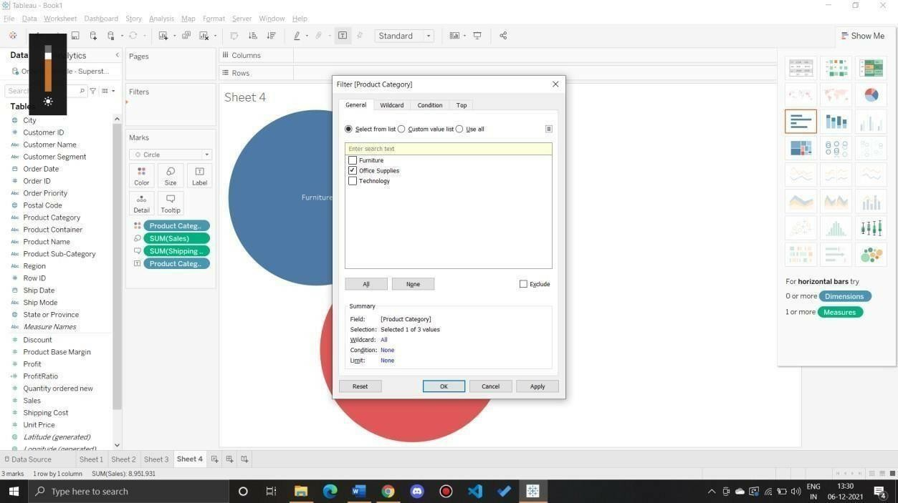

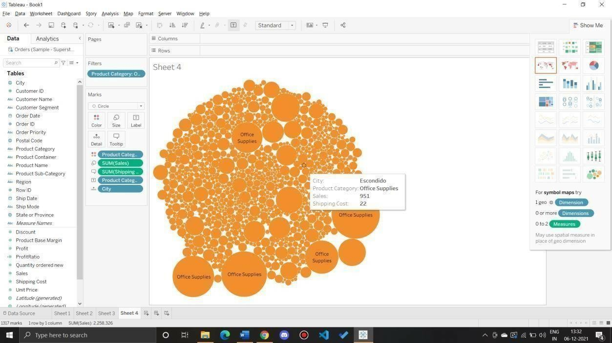

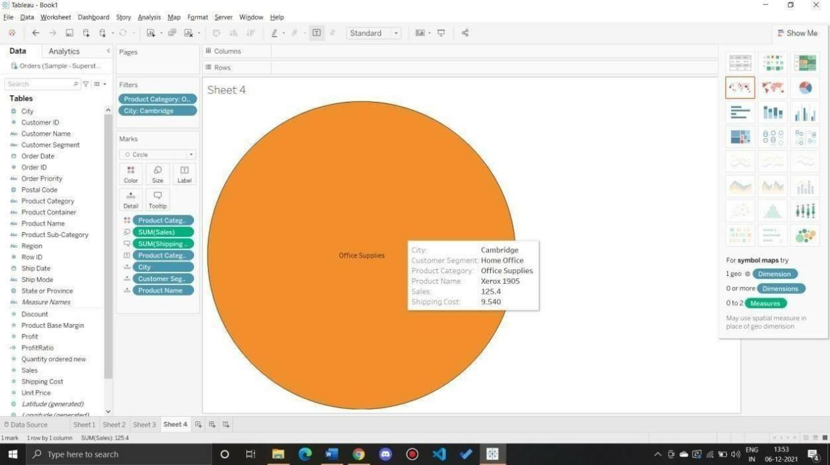

Preparing Maps

Data Set for this Lab Sample- Superstore

Q 1: Prepare a Geographic map to show sales in each state. Ans:

a) Connect to dataset

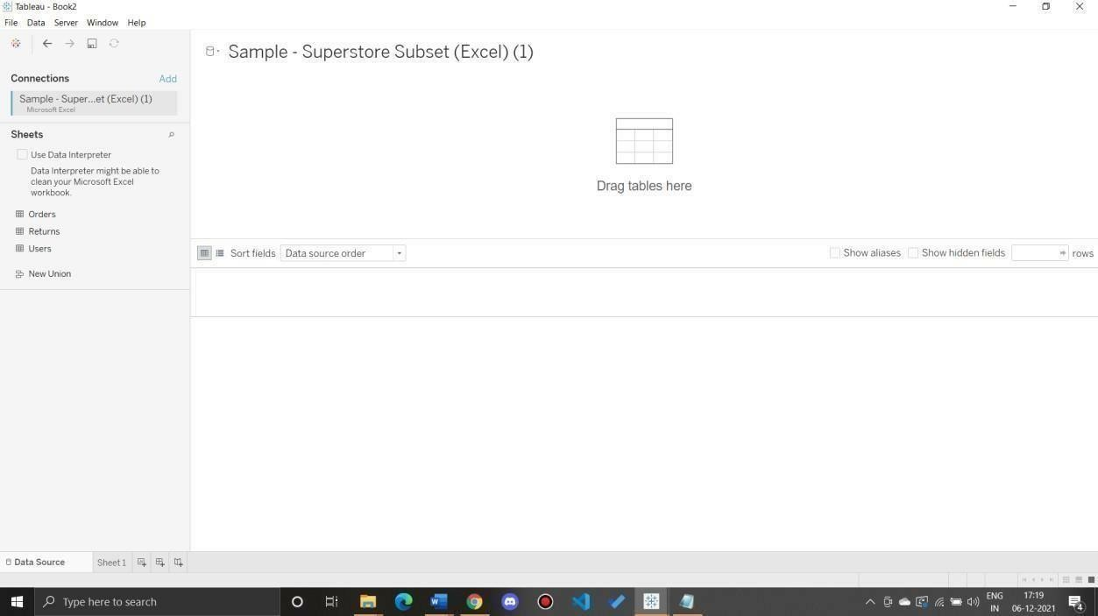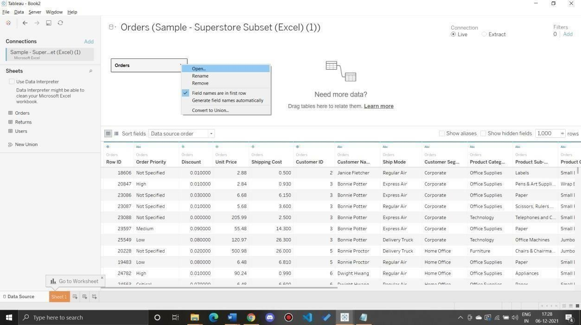

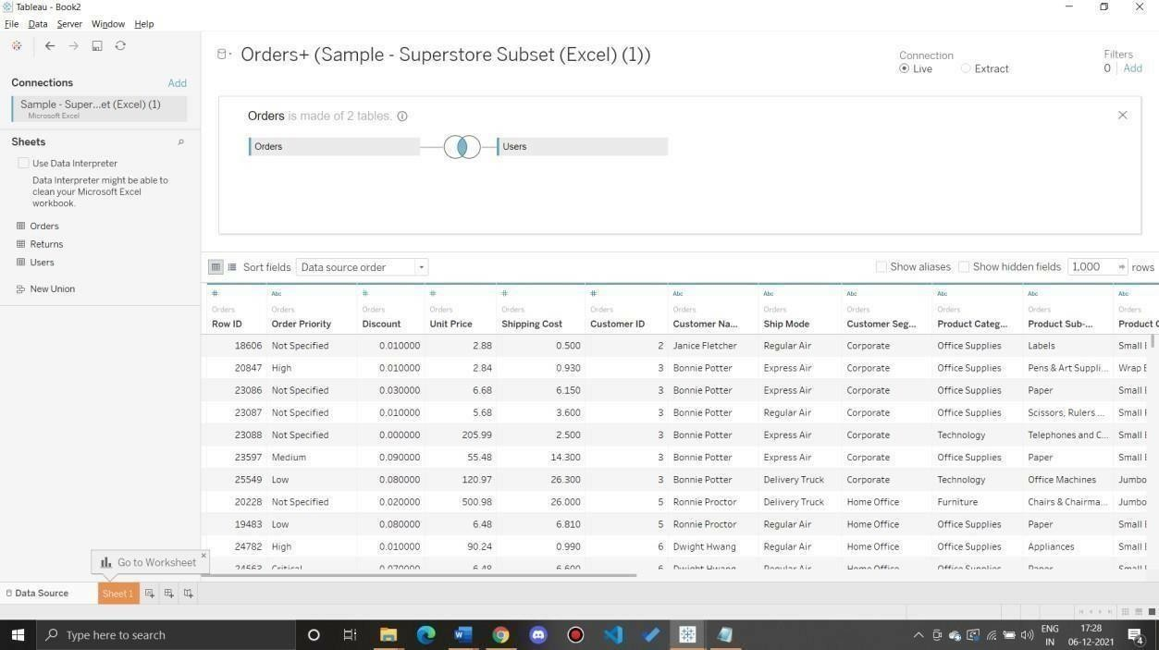

Create a Geographic Hierarchy

In the Data pane, right-click the geographic field, Country, and then select Hierarchy > Create Hierarchy.

In the Create Hierarchy dialog box that opens, give the hierarchy a name, such as Mapping Items, and then click OK.

At the bottom of the Dimensions section, the Mapping Items hierarchy is created with the Country field.

In the Data pane, drag the State field to the hierarchy and place it below the Country field.

Repeat step 3 for the City and Postal Code fields.

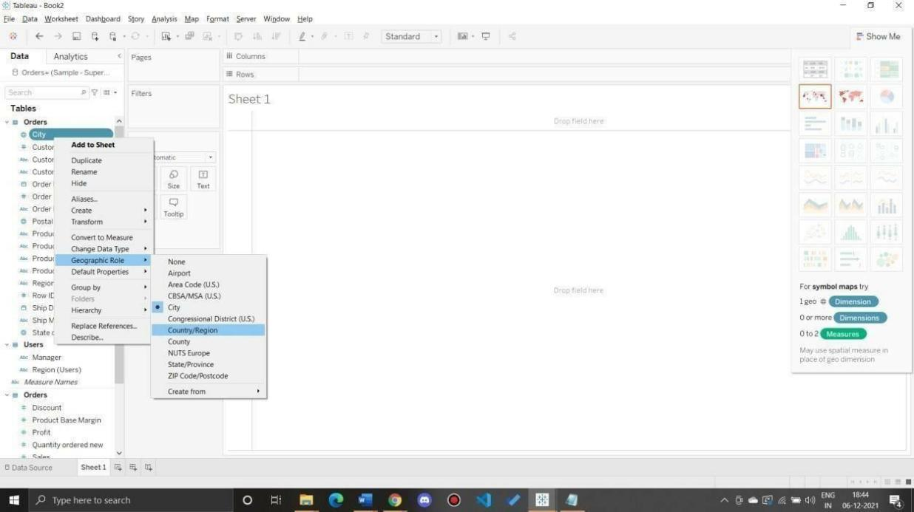

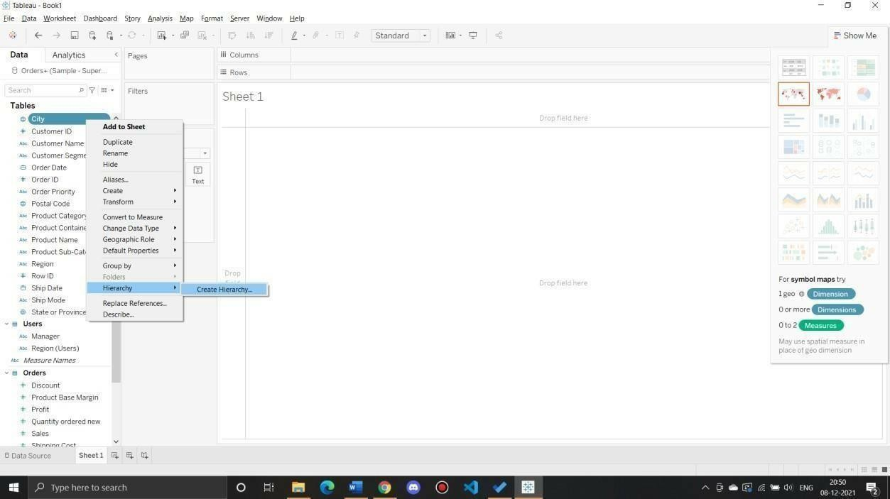

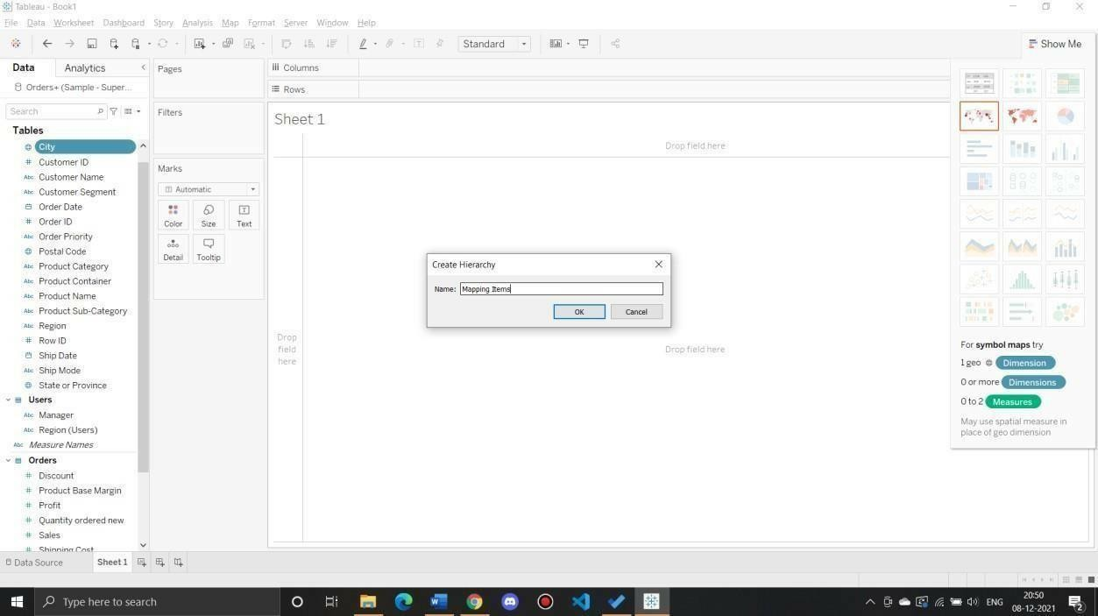

Build a basic map

1) In the Data pane, double-click City**.

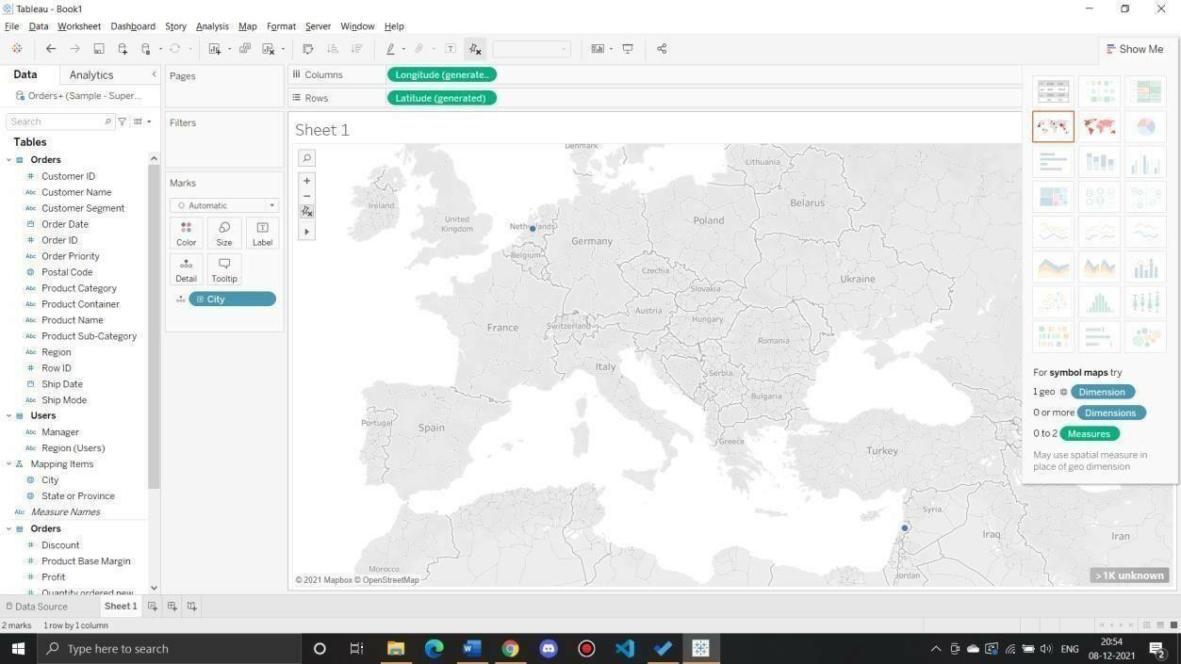

Add visual detail Add color

From Measures, drag Sales to Color on the Marks card.

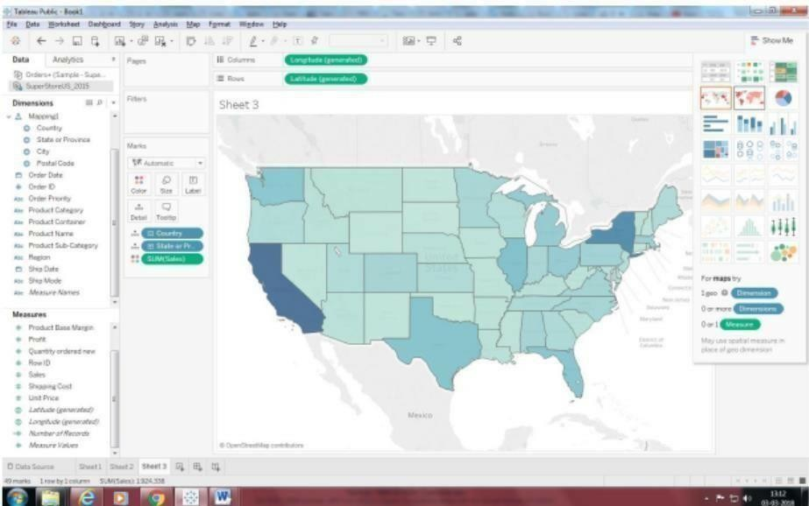

Add labels

From Measures, drag Sales to Label on the Marks card.

Each state is labeled with sum of sales. The numbers need a little bit of formatting, however.

In the Data pane, right-click Sales and select Default Properties > Number Format.

In the Default Number Format dialog box that opens, select Number (Custom), and then do the following:

For Decimal Places, enter 0.

For Units, select Thousands (K).

Click OK.

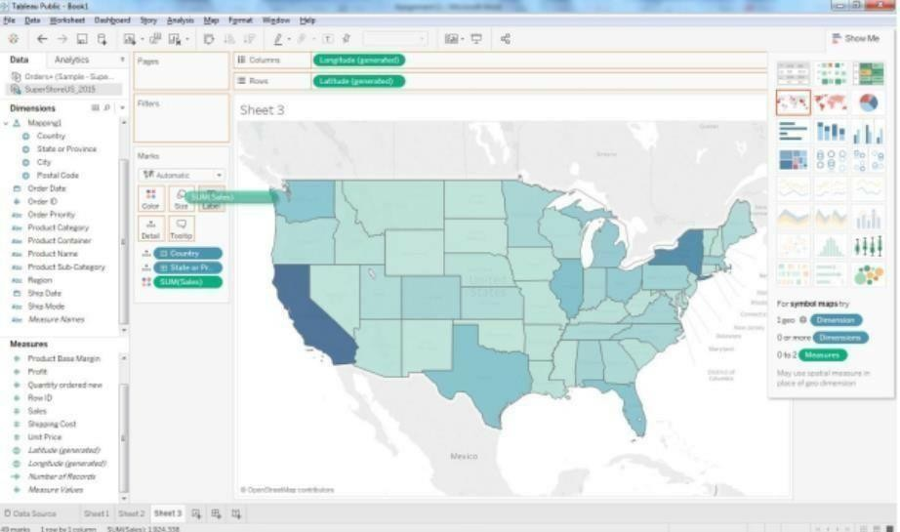

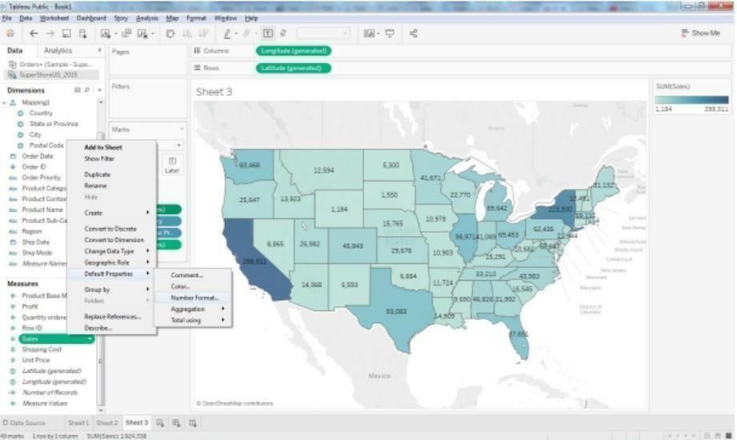

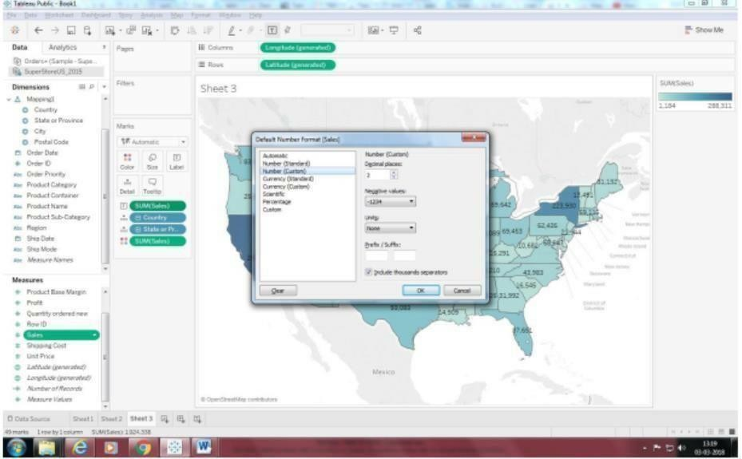

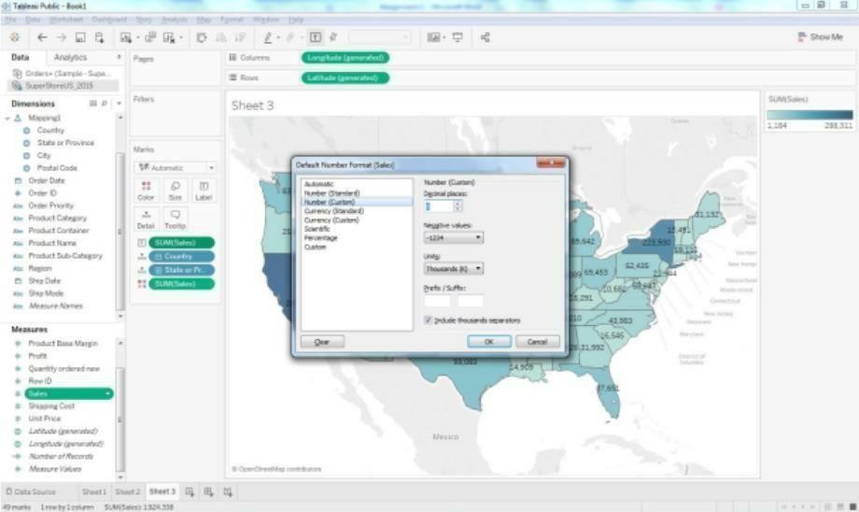

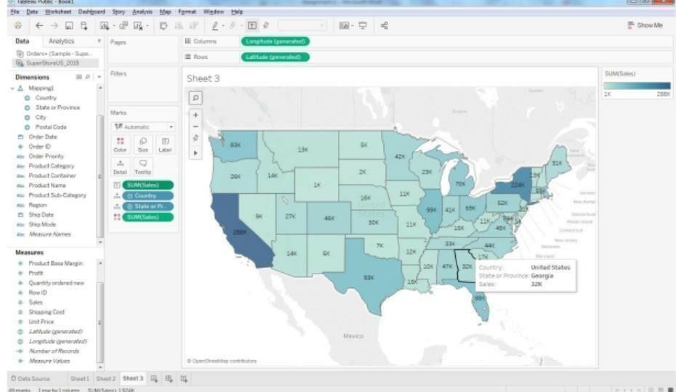

Q 2: Show Profit Ratio of each state as tooltip on map

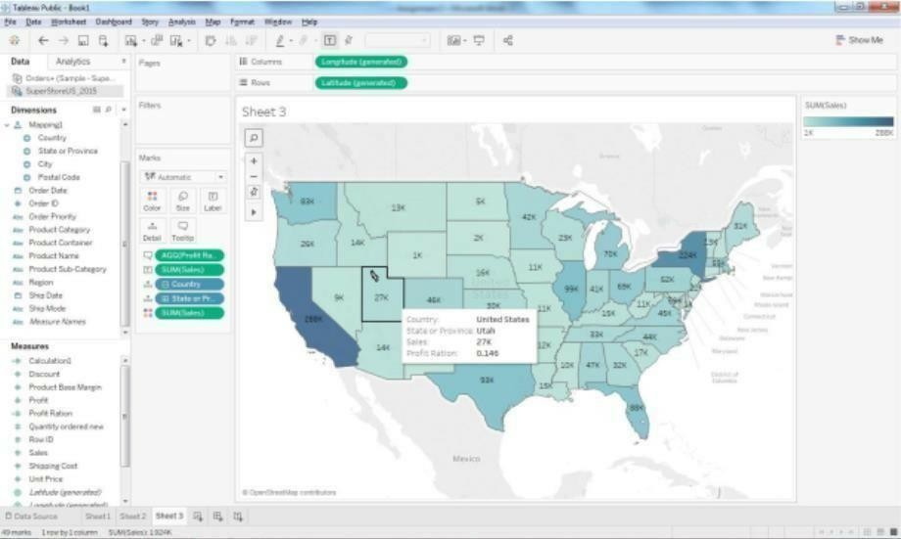

Q 3: Show Profit ratio for Grip Envelop products

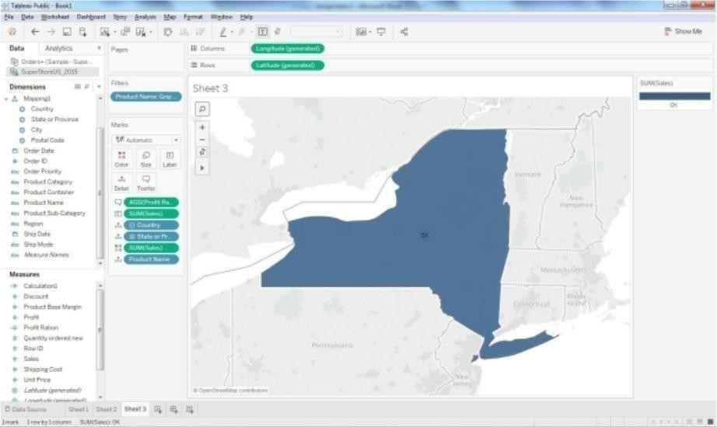

Q 4: In the technology product category which unprofitable state is surrounded by only profitable states.

Drag the product category on the filter shelf and

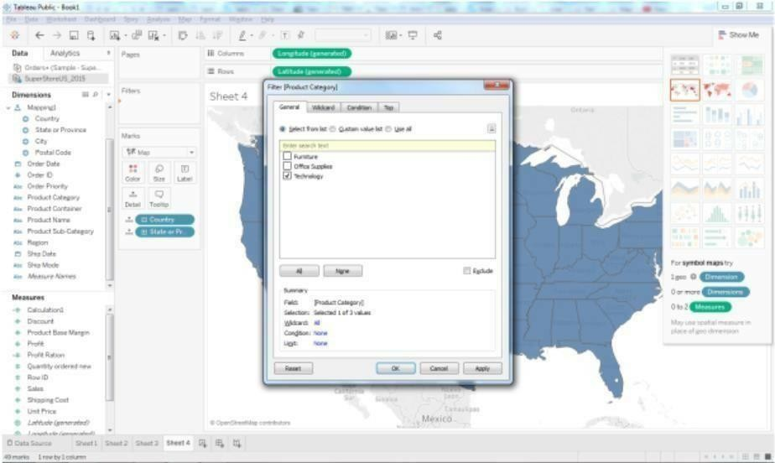

select in technology.

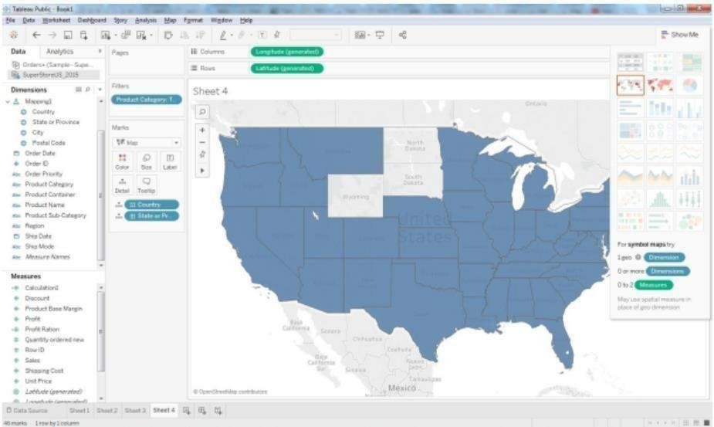

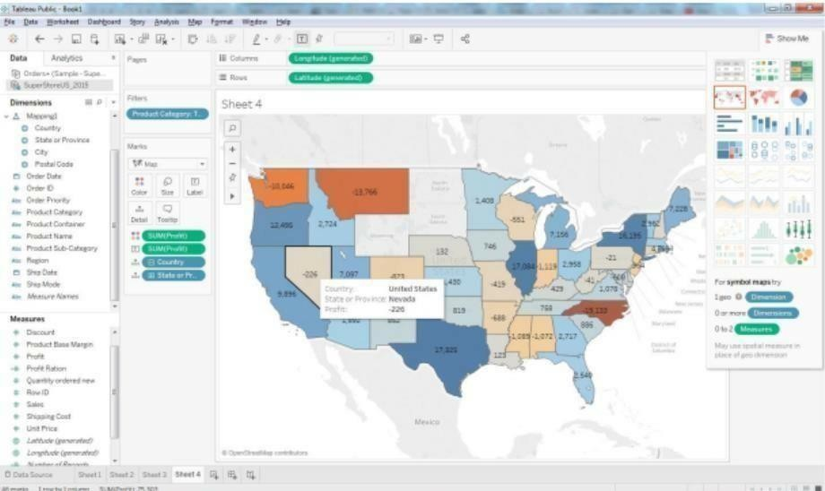

Add profit Label.

Now we can see Nevada State is surrounded by profitable states.

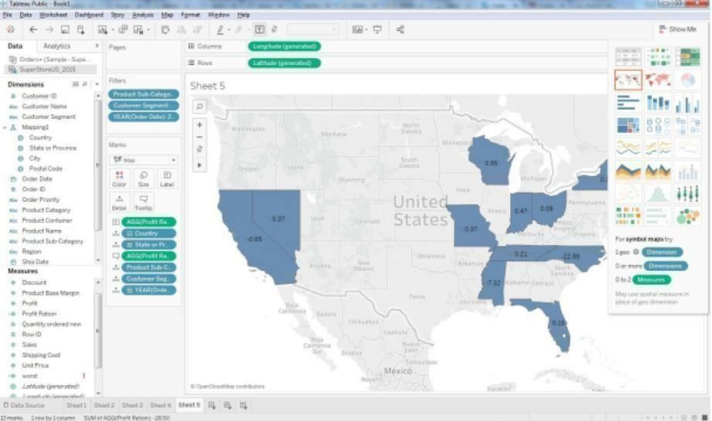Q 5: Which state has the worst Gross Profit Ratio on Envelopes in the Corporate Customer Segment that were Shipped in 2015?

Preparing Reports

Data Set: Super store

Prapare a report showing product category wise sales

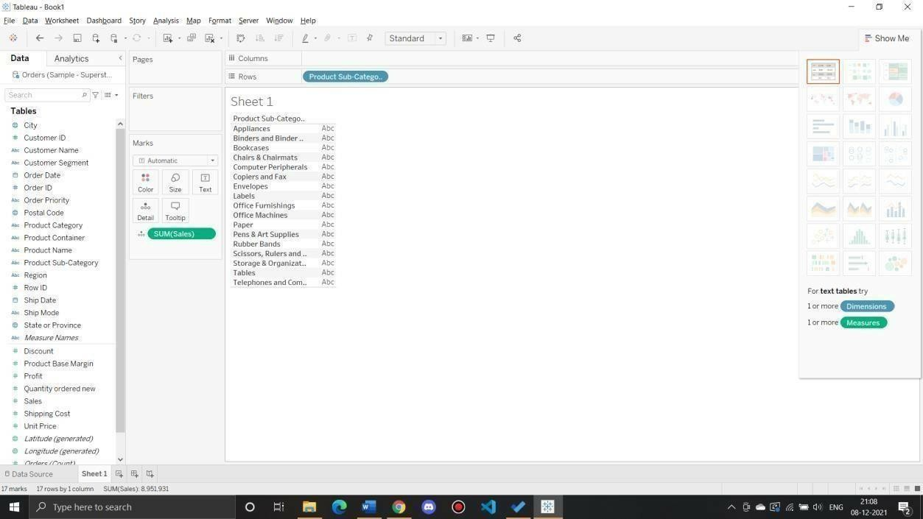

Report showing regionwise productwise sales

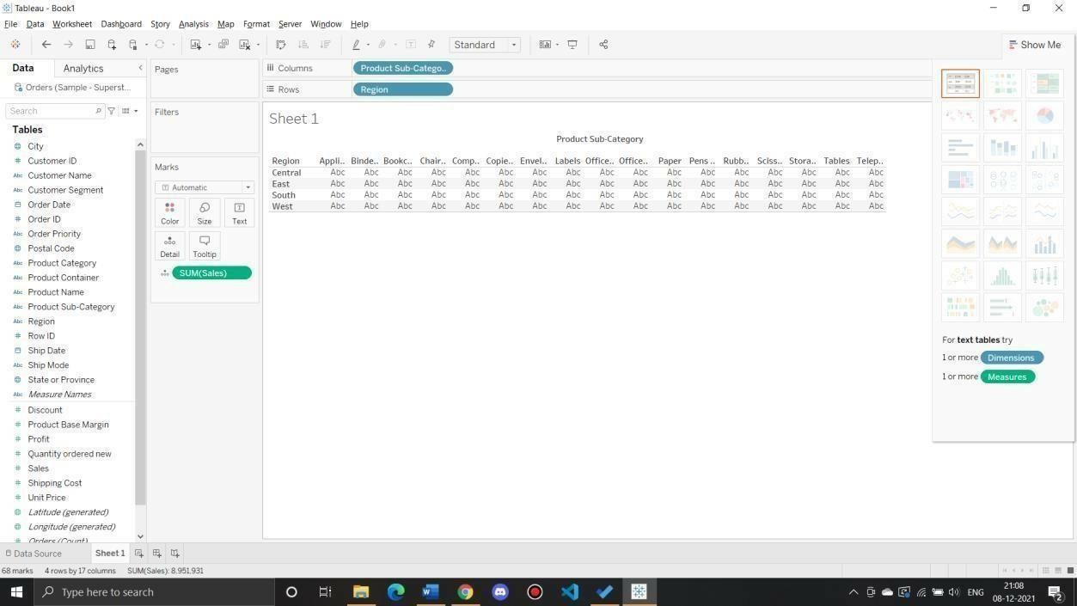

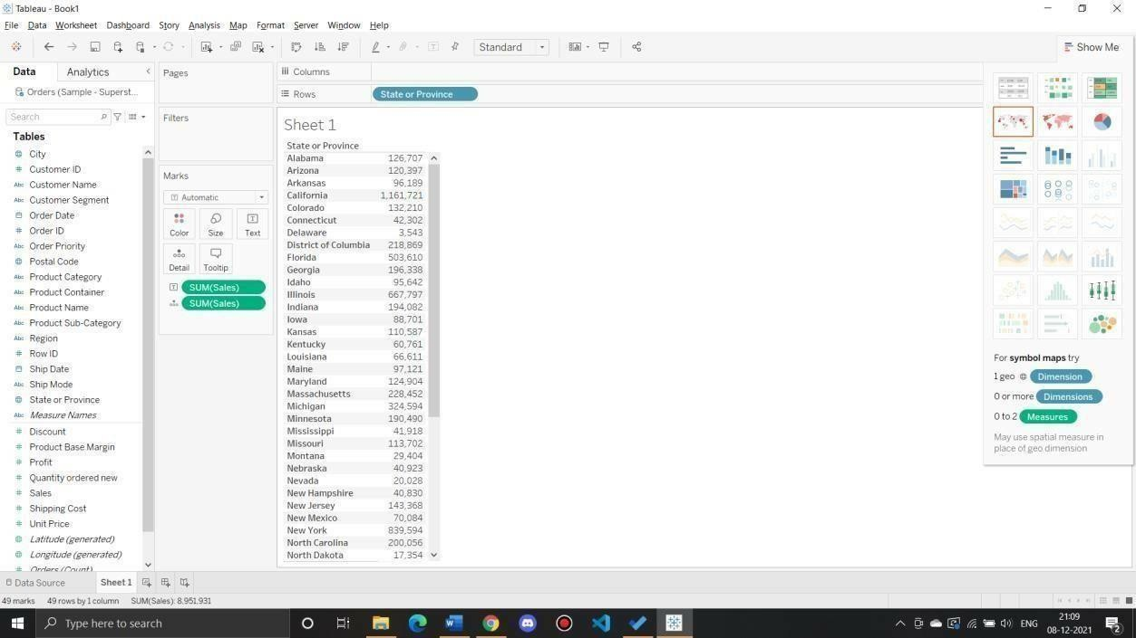

What is the percent of total Sales for the ‘Home Office’ Customer Segment in July

of 2014?

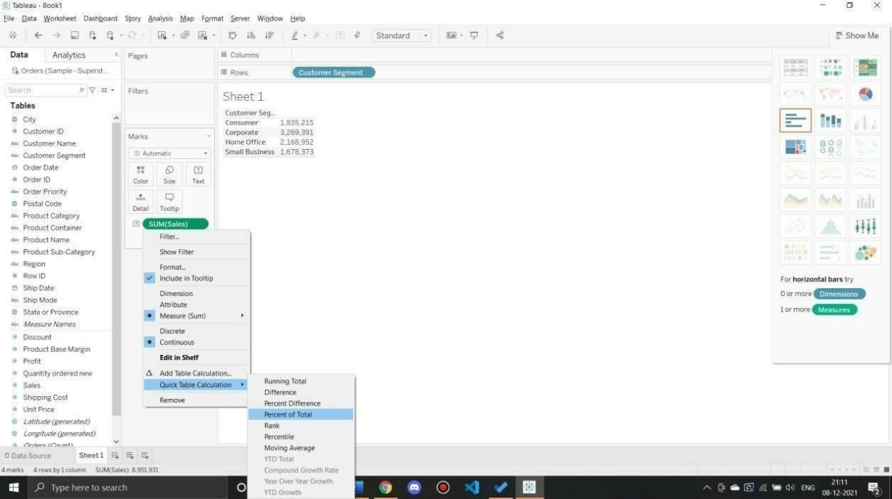

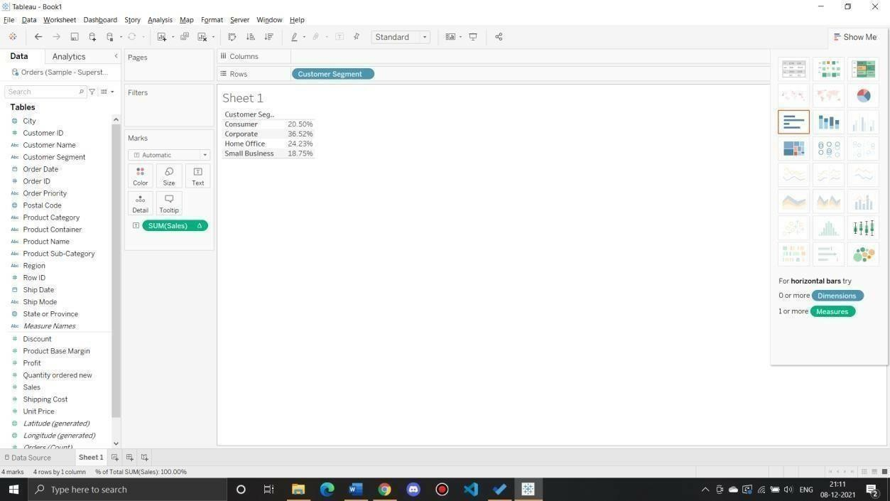

Find the top 10 Product Names by Sales within each region. Which product is ranked #2 in both the Central & West regions in 2015?

Drag “Product Name” dimension from data pane window to Row Shelf and then add an “order Date” on Filter shelf and select “Year” of Order date as 2015.After that put region on Filter shelf and select “Central” and “West” checkbox. Also, put a copy of region to the Column shelf as well.

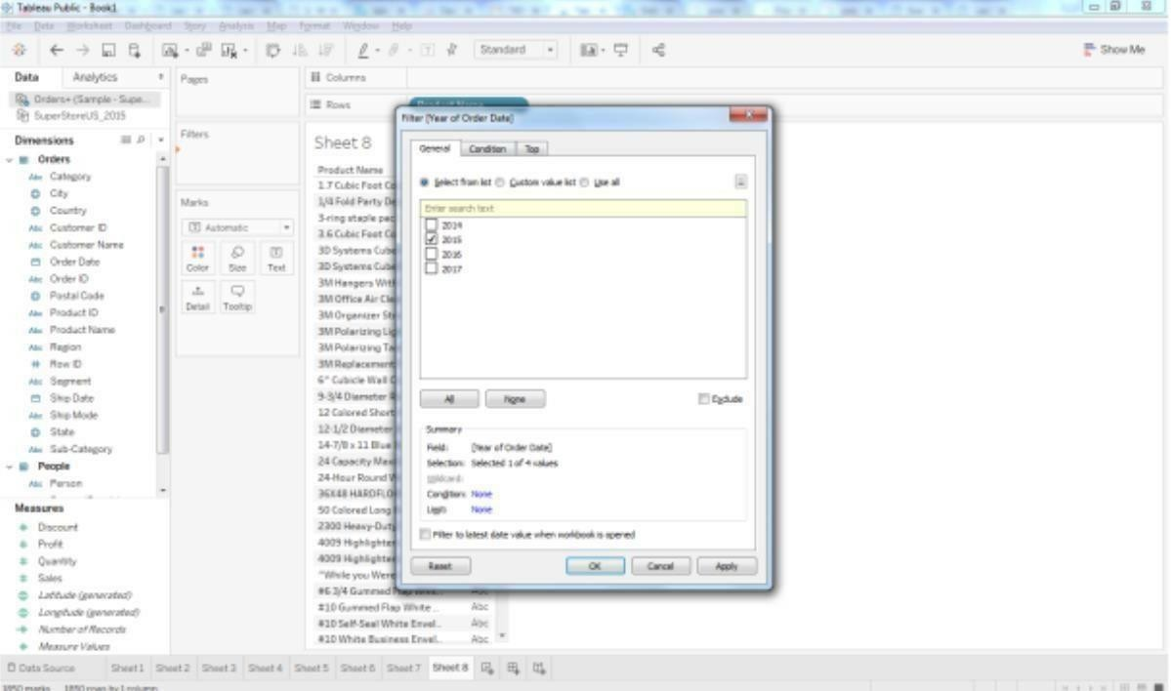

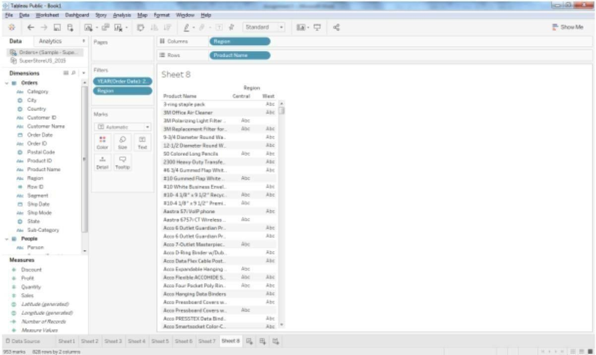

Drag a Sales measure to the text label. So for getting the Top 10 “product name” by sales, we

need to

add the “Product name” on Filter shelf. Once the Filter Pop up is open, Select “TOP” tab >By Field > Top 10 by Sum (Sales).

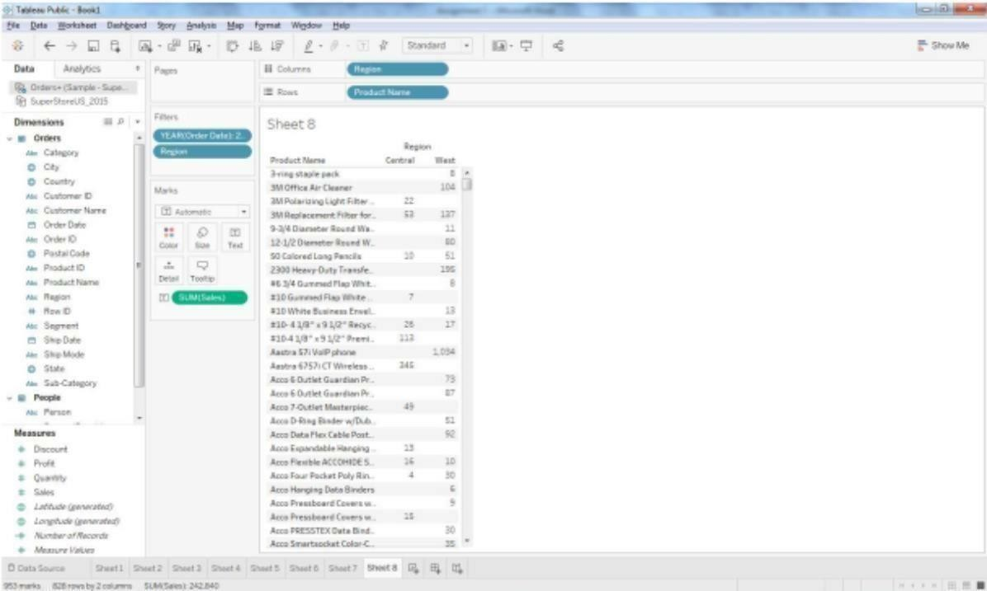

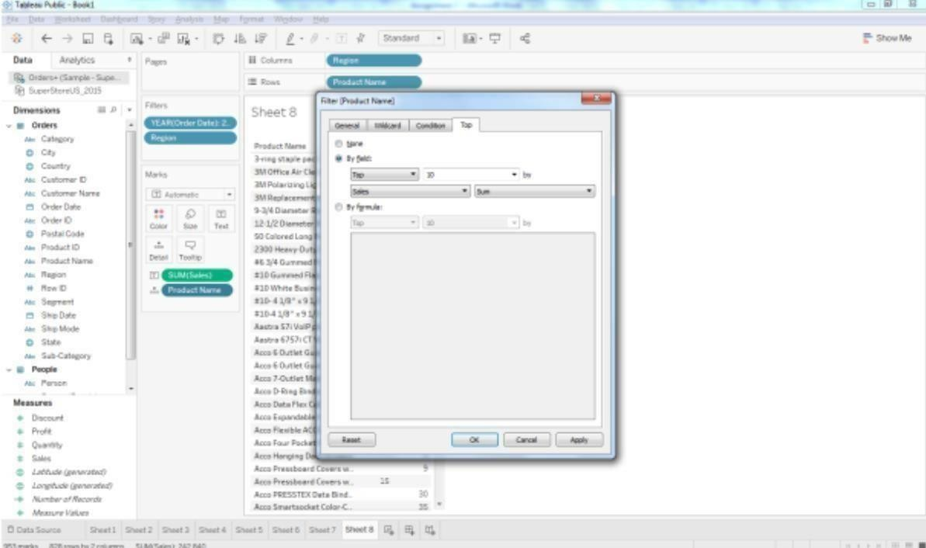

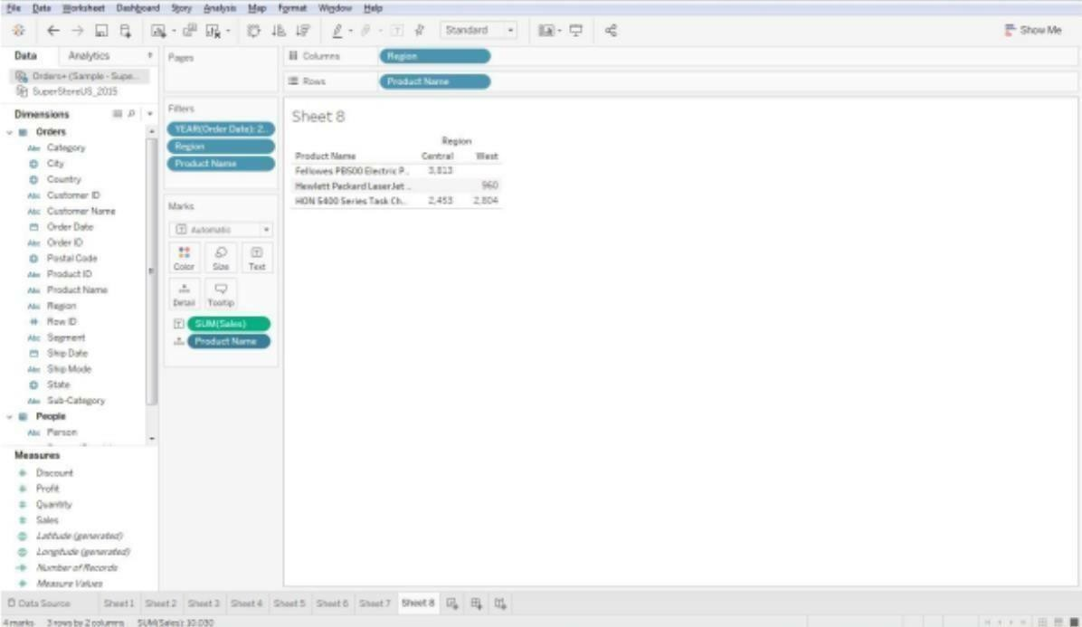

Right click on the aggregated Sales measure and click on arrow sign then select Quick Table Calculation > Rank. As the default addressing is Table across, please change it into Table Down (Compute using -> Table Down).

